TABLE OF CONTENTS

1.0 Introduction of the project…………………………………………………………………………….1
2.0 Background of study site……………………………………………………………………………….2
3.0 Methodology …………………………………………………………………………………………………7
4.0 Analysis…………………… ...…………………………………………………………………………………8
5.0 References……………………………………………………………………………………………………17

1.0 INTRODUCTION OF THE PROJECT

This project aims to conduct a cross-sectional and longitudinal research on tourism promotion issues of multi-cultural exchanges between four ASEAN countries (Japan, Vietnam, Thailand and Malaysia). It creates the links between research and academic programs in these four countries and through this, it is hoped that education awareness would be raised. Funded by the Japan Foundation Grant of Tourism Research Promotion, this project involves four (4) universities: Kyoto University of Foreign Studies (KUFS) (Japan), Chiang Mai University (CMU) (Thailand), Hanoi University (HANU) (Vietnam) and Universiti Sains Malaysia (USM) (Malaysia).

Kyoto, Hanoi, Chiang Mai and Penang have been chosen as the case studies, which are rich with heritage and cultural elements. Some of these elements have received international recognition and been awarded the World Heritage Site title by the United Nations Educational, Scientific and Cultural Organisation (UNESCO). The international recognition which attracts high number of visitations hence leads to the importance of understanding factors contributing to tourism development and its longevity. Thus, this project assesses the tourist segmentation, image of the city, tourist motivation and travel satisfaction; from the international tourists perspective.

This project seeks: (i) to understand and evaluate the culture and heritage issues in the selected four cities; (ii) to discover what are the culture and heritage differences between the selected four cities; and (iii) to understand how tourism affects or get affected by culture and heritage.

Self-administered questionnaire survey was undertaken in five (5) tourist attractions in Chiang Mai, namely: Karen Long Neck Camp, Doi Pui Hmong Hill Tribe Village, Bhubing Palace, Wat Phratat Doi Suthep and Mae Sa Elephant Camp. 120 survey forms were distributed to the international tourists from 19th to 23rd November 2016. Of 120, this project has successfully retrieved 107 completed forms.
2.0 BACKGROUND OF STUDY SITE

Chiang Mai sometimes written as "Chiengmai" or "Chiangmai", is the largest and most culturally significant city in Northern Thailand (see Figure 1). It is the capital of Chiang Mai Province and was a former capital of the Kingdom of Lan Na (1296–1768), which became the Kingdom of Chiang Mai, a tributary state of Siam from 1774 to 1899 and finally the seat of a merely ceremonial prince until 1939. Nestled amongst forested foothills, Chiang Mai is much older than it first appears. Chiang Mai is home to many historically and culturally interesting sites and temples. The city also referred to as the “Rose of the North”, has a reputation for its cool weather, pretty girls, historic temples and mountainous jungle surroundings.

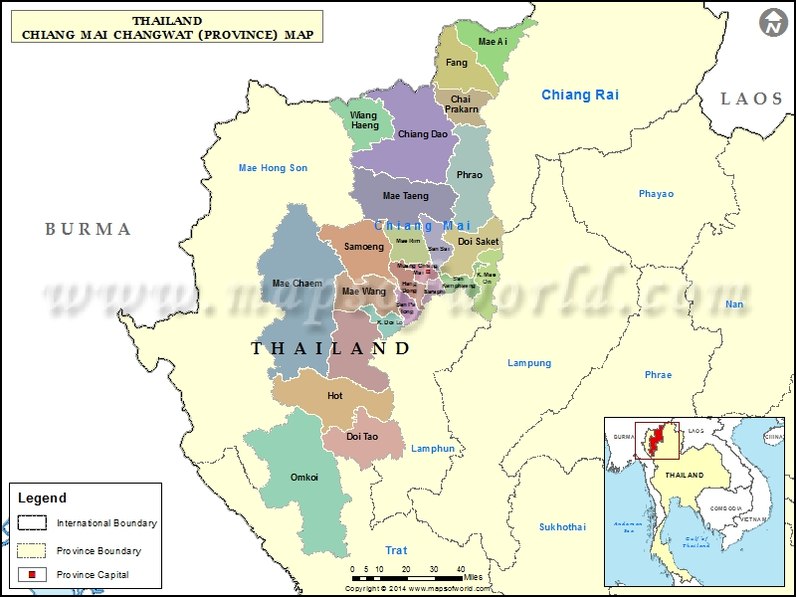
Figure 1: Location of Chiang Mai
Source: Maps of World (2016)

During the city's medieval heydey, almost everything was made of teak hauled by elephant from the surrounding rainforest, with the notable exception of its towering wát. The monasteries still remain, centred on ancient brick chedi (stupas) in a remarkable range of shapes and styles, but the gaps between them have been filled in with modern Thai houses and traveller hotels. Despite this, the historic centre of Chiang Mai still feels overwhelmingly residential, more like a sleepy country town than a bustling capital.
Chiang Mai is 700km north of Bangkok and is nestled in a valley 310 meters above the sea level. The province has a total land area of 10,107 square meters. The widest point of the province measures 136 km or 85 miles, and the longest 320 km or 200 miles. To the north, a 277 km or 141.82 miles stretch of mountains divides Chiang Mai’s northern districts of Fang and Mae Ai from Myanmar’s Chiang Tung (Shan) State. In certain sections, the Kok River acts as a border between Chiang Mai and Myanmar. On the east, Chiang Mai is bordered by the Chiang Rai, Lampang, and Lamphun provinces. The Mae Tuen River, Ream Mountain, and Luang Mountain separate Chiang Mai’s South from the province of Tak. Some portions of Chiang Mai’s south also border the Lamphun province. To the west, Chiang Mai is bordered by Mae Hong Son province. The population of the Chiang Mai province stands at around 1,600,000 although the city itself has an estimated 170,000 people. There are mountains all around the valley rising to the heights of more than 2,500 meters. Doi Inthanon is the highest mountain peak in Chiang Mai that stands at 2,565 meters. Chiang Mai enjoys three main seasons which are cool (October to February), summer (February to May) and rainy (June to October).

Tourism is a major economic factor in the Kingdom of Thailand. Due to the increased tourist's arrival (see Table 1), the estimated tourism receipts that directly contributing to the Thai GDP of 12 trillion baht is ranged from nine percent (1 trillion baht) (2013) to 16 percent. When including indirect travel and tourism receipts, in 2014, the total estimated tourism contribution accounts for 19.3 percent (2.3 trillion baht) of Thailand's GDP.

Year | Arrivals | % Change
2015 | 29,881,091 | +20.44%
2014 | 24,809,683 | -6.54%
2013 | 26,546,725 | +18.8%
2012 | 22,353,903 | +15.98%
2011 | 19,230,470 | +20.67%
2010 | 15,936,400 | +12.63%
2009 | 14,149,841 | −2.98%
2008 | 14,584,220 | +0.83%
2007 | 14,464,228 | +4.65%
2006 | 13,821,802 | +20.01%
2005 | 11,516,936 | −1.15%
2004 | 11,650,703 | no data
Table 1: Statistics of tourists’ arrival in the Kingdom of Thailand.
Source: Wikipedia (2016)

TOURISM SITES VISITED IN CHIANG MAI

In Thai eyes, Chiang Mai is considered a major city after Bangkok and it is also seen as an exuberant city of art and culture – both traditional and contemporary. Chiang Mai has always sold itself on its culture and natural beauty. Tourism replaced commercial trade as Chiang Mai’s number one source of outside revenue by the mid-1960s. Chiang Mai has recently received various prestigious international awards such as second place in Travel+Leisure’s 2010 World’s Best Awards for top world city; Bangkok was hailed in the first place (Robinson, 2012). For the purpose of understanding the reality of Chiang Mai’s tourism industry, visitations were made to the following tourism spots in Chiang Mai.

Night Bazaar, every evening, the centre of Chiang Mai comes alive with the massive Night Market that stretches for several blocks and includes restaurants, bars and entertainment. The Chiang Mai Night Market is considered legendary and certainly one of the cheapest places for tourists to shop in Thailand, owing to its close proximity to the source of products and the lower cost of living in Chiang Mai. It is situated along a three-block stretch of Chan Klan Road in the heart of the city and within walking distance of most hotels (Virtual Travel Guides, 2010)

San Kamphaeng Hot Springs: San Kamphaeng Hot Springs is an ideal destination for those interested in health and well-being. A natural spring emitting water with high sulphur content, the spring is said to cure ailments and rejuvenate the body. The water has a temperature in excess of 100 degrees centigrade and the area is so active that there is ongoing research into how to tap the springs as a potential energy resource (Discovery Thailand, 2016).

Bo Sang Umbrella Village: Bo Sang is a tiny town lies just 15 km to the west of Chiang Mai; The making of umbrellas in Bo Sang (Bor Sarng) village is a handicraft occupation of the villagers which has made its name known throughout the country and abroad until the parasol has become one of the symbols of Chiang Mai (Lush 2016).

Three Kings’ Monument: One of Chiang Mai’s most popular landmarks is the Three Kings Monument located on Prapokkloa Road in the heart of the Old Town. Several historical museums opened their doors in recent years within the surrounding of the Three Kings Monument, making the area to a new centre of museums in Chiang Mai. The three statues portray King Mengrai, the founder of Chiang Mai, King Ngam Muang of Phayao and King Khun Ram Khamhaeng of Sukhothai who all worked closely together on the development of Chiang Mai in the 13th century. These museums are now in buildings which previously served as the city’s municipal buildings.

Sunday Walking Street: Walking Street Market starts at Thapae Gate and runs along the length of Ratchadamnoen Road through the heart of the Old City and has become a Chiang Mai institution. It is a real showcase of the art and craftsmanship of Northern Thailand. The street, which is closed entirely to traffic, is a focal point for local people to meet, browse, socialise, haggle and enjoy. The numbers are considerably swelled by both Thai and foreign visitors to Chiang Mai and the whole area buzzes with the kind of excitement that can only be generated by a large number of people at leisure (Hitchman IT, 2016).

Mae Sa Elephant Camp: Mae Sa Elephant Camp is a 30-minute drive from Chiang Mai. Mae Sa Elephant Camp Chiang Mai is a privately owned elephant camp less than one hour from Chiang Mai. It is located in an idyllic forested setting with a waterfall, and the camp currently has 73 elephants and approximately 80 mahouts. Although technically owned by the camp, most of the elephants go home with the mahout to their villages each night (Tourism Authority of Thailand1, undated).

Queen Sirikit Botanical Garden: Queen Sirikit Botanic Garden (QSBG), or formerly known as Mae Sa Botanic Garden, is one of the most beautiful gardens in the whole of Thailand. This garden is situated in the foothills of the Doi Sutep-Pui national Park. It is the first botanical garden in the country at international standards for there are scientific basis and purposes for the collections and the provision of botanical education and research. The main objectives of the Garden are to serve as a centre of Thai flora for botanical study and research, to render services concerning biodiversity and environmental conservation, as well as to provide an aesthetic place for the general public (Thai Guide to Chiang Mai, 2011).

Wat Phratat Doi Sutep: Overlooking the city from its mountain throne, Wat Phratat Doi Sutep is one of northern Thailand's most sacred temples, and it is located 15km from the city of Chiang Mai. The Wat Phratat Doi Sutep itself is a beautiful example of northern Thai architecture, reached via a strenuous, 306-step staircase flanked by a mosaic naga (serpents) (Lonely Planet1, undated).

Bhubing Palace: Bhubing Palace is a beautiful and famous tourist attraction located on Buak Ha Mountain, Suthep sub-district, Mueang district, Chiang Mai province. It was built by the order of King Rama V in 1961 to be used as a residence when he came to stay in Chiang Mai. It was also used to receive royal guests at different occasions. The climate here is cool throughout the year. It is surrounded by charming topography among mild fog in contrast with winter flowers well-arranged along the sidewalks leading to the palace. The internal area comprises Phrueksa Wisuitthikhun Palace, a two-storey building with a ground floor on the hillside; Siri Song Bhubing Palace that used eucalyptus wood for constructing a log cabin; and a two-storey applied Thai style guesthouse that was used as a residence for royal guests and senior civil servants accompanying the king (Tourism Authority of Thailand, 2016).

Doi Pui Hmong Hilltribe Village: Doi Pui Hmong Hilltribe Village is located on Doi Sutep, a 1673 meter high mountain that is the focal point of Doi Sutep and Doi Pui National Park. The Village is about 4km away from Wat Phratat Doi Sutep. The Village offers an insight into how Thailand tribes live. The villagers wear traditional Hmong clothes, sell traditional Hmong handicrafts and live in traditional Hmong-style homes (My Chiang Mai Tour, undated).
Karen Long Neck Camp: The Long Neck Karen is a tribe of women that are refugees from Burma living in the northern Thai hills. Mistreated in their own country, they fled to Thailand where they earn an income from tourism and an education for their children in Thai schools. The brass neck rings weigh around 10 pounds (or 4.5 kilogrammes) and they can have up to an additional 30 pounds of rings that they wear on their arms and legs weighing them down. It is said the neck rings prevented bites from tigers and the women themselves say it is to distinguish their cultural identity. Anthropologists have hypothesised the rings are worn to prevent slavery by making the women less attractive to other tribes (Luxe Adventure Traveler, 2016).

3.0 METHODOLOGY

Employing stratified random sampling technique, the survey was conducted either face-to-face interviews with the respondents by enumerators or by self-completion at selected tourist attraction in Chiang Mai (e.g. Karen Long Neck Camp, Doi Pui Hmong Hill tribe Village, Bhubing Palace, Wat Phratat Doi Sutep, Mae Sa Elephant Camp) and the gateways to Chiang Mai namely Chiang Mai International Airport, Thailand. Enumerators screening the respondents at the beginning, to verify that the respondents were a tourist and not the day trippers and transients visitors.

4.0 ANALYSIS

PROFILE OF VISITOR

Gender | Frequency | Total
Male | 45 | 42.1%
Female | 62 | 57.9%
Total | 107 | 100.0%
Age
18-25 years old | 26 | 24.3%
26-35 years old | 39 | 36.4%
36-49 years old | 21 | 19.6%
≥ 50 years old | 21 | 19.6%
Total | 107 | 100.0%
Marital status
Single | 57 | 53.3%
Married | 46 | 43.0%
Divorce/widowed | 4 | 3.7%
Total | 107 | 100.0%
Highest Level of Education
Higher Degree – Master/PhD | 33 | 30.8%
Tertiary Education-Diploma/Degree | 64 | 59.8%
Secondary/High School Education | 10 | 9.3%
Primary/Elementary Education | 0 | 0.0%
No Formal Education | 0 | 0.0%
Total | 107 | 100.0%

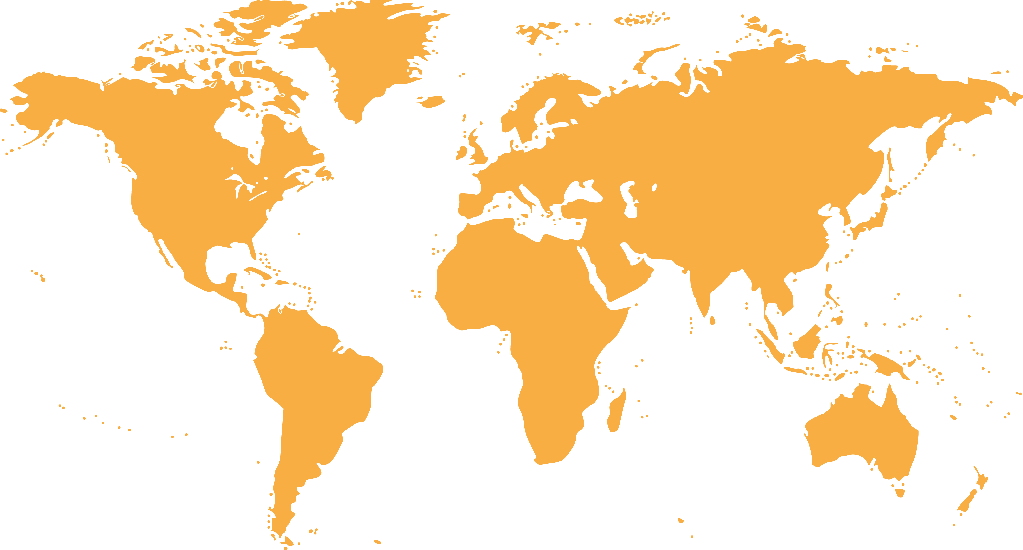

24.3%
Eastern
Asia

3.7%
Oceania

11.2%
Southeast
Asia

0.9%
Southern
Asia

0.0%
Africa

0.9%
Western
Asia

37.4%
Europe

21.5%
Americas

Country of residence | Frequency | Total
Southeast Asia | 12 | 11.2%
Western Asia | 1 | 0.9%
Eastern Asia | 26 | 24.3%
Oceania | 4 | 3.7%
Europe | 40 | 37.4%
Americas | 23 | 21.5%
Sothern Asia | 1 | 0.9%
Africa | 0 | 0.0%
Total | 107 | 100%

MAIN PURPOSES OF TRAVEL

1. Leisure
2. Culture and heritage
3. Education

Main Purpose of Travel | Frequency | Total
Leisure/recreation | 80 | 74.8%
Culture and heritage | 18 | 16.8%
Education/teaching/training | 4 | 3.7%
Shopping | 3 | 2.8%
Business/meeting | 1 | 0.9%
Others | 1 | 0.9%
Visit friends/relatives (VFR)/back to hometown | 0 | 0.0%
Health treatment | 0 | 0.0%
Convention/conference/trade show/ exhibition | 0 | 0.0%
Religious/pilgrimages | 0 | 0.0%
Sporting | 0 | 0.0%
Total | 107 | 100.0%

IMAGES OF CHIANG MAI

The majority of visitors perceived the images of Chiang Mai as:

1. World Heritage Site
2. Local Cuisine
3. Safe Destination

Image of Chiang Mai | Frequency | Total
World Heritage Site | 53 | 39.6%
Local Cuisine | 34 | 25.4%
Safe Destination | 9 | 6.7%
Multicultural society | 8 | 6.0%
Traditional | 7 | 5.2%
Nightlife Entertainment | 6 | 4.5%
Shopping Paradise | 4 | 3.0%
Sandy Beaches | 4 | 3.0%
Cultural Performance | 3 | 2.2%
Education Hub | 3 | 2.2%
Hills/jungles/green | 1 | 0.7%
Modern City Life | 1 | 0.7%
International events | 1 | 0.7%
Healthcare Destination | 0 | 0.0%
Total | 134 | 100.0%

FACTORS INFLUENCED VISITOR’S DECISION TO TRAVEL

Statement | Not Influential at all | A little bit Influential | Somewhat influential | Influential | Very Influential | Total
Positive Image | 6.5% | 0.9% | 24.3% | 39.3% | 29.0% | 100%
Heritage sites, culture, arts and tradition | 1.9% | 5.6% | 15.0% | 40.2% | 37.4% | 100%
Friendliness of local people | 6.5% | 1.9% | 12.1% | 34.6% | 44.9% | 100%
Safety level of destination | 7.5% | 4.7% | 15.9% | 35.5% | 36.4% | 100%
Convenience of Visa | 15.9% | 14.0% | 20.6% | 15.9% | 33.6% | 100%
Affordability of the destination | 5.6% | 5.6% | 24.3% | 29.0% | 35.5% | 100%
Urban landscape | 5.6% | 12.1% | 33.6% | 31.8% | 16.8% | 100%
Food | 2.8% | 3.7% | 14.0% | 38.3% | 41.1% | 100%
Natural scenery | 1.9% | 0.9% | 14.0% | 33.6% | 49.5% | 100%
Geographically close | 21.5% | 12.1% | 20.6% | 22.4% | 23.4% | 100%
Climate | 7.5% | 6.5% | 21.5% | 32.7% | 31.8% | 100%
Hygiene level | 9.3% | 21.5% | 27.1% | 20.6% | 21.5% | 100%
Beautiful beaches | 26.2% | 12.1% | 19.6% | 19.6% | 22.4% | 100%
Shopping experience | 21.5% | 15.0% | 26.2% | 23.4% | 14.0% | 100%
Festival and events | 12.1% | 9.3% | 31.8% | 27.1% | 19.6% | 100%
Nightlife | 25.2% | 13.1% | 26.2% | 18.7% | 16.8% | 100%
Outdoor activities | 9.3% | 10.3% | 22.4% | 41.1% | 16.8% | 100%
Level of ICT infrastructure | 16.8% | 15.0% | 31.8% | 20.6% | 15.9% | 100%
Status of destination (e.g. world heritage) | 7.5% | 11.2% | 32.7% | 31.8% | 16.8% | 100%
Interesting amusement/theme parks | 29.9% | 12.1% | 28.0% | 15.9% | 14.0% | 100%
Similarity of culture | 32.7% | 15.9% | 21.5% | 18.7% | 11.2% | 100%
Same religion | 48.6% | 16.8% | 11.2% | 13.1% | 10.3% | 100%
Statement | Not Applicable | Poor | Below Average | Average | Good | Excellent
Hospitality of immigration officials at the entrance point | 3.7% | 1.9% | 10.3% | 32.7% | 31.8% | 19.6%
Check in/check-out process at the airport | 3.7% | 0.9% | 4.7% | 31.8% | 37.4% | 21.5%
Availability of information at entry points | 3.7% | 1.9% | 12.1% | 36.4% | 26.2% | 19.6%
Local public transport services | 3.7% | 3.7% | 8.4% | 26.2% | 36.4% | 21.5%
Accessibility of tourist attractions | 0.9% | 0.9% | 3.7% | 21.5% | 47.7% | 25.2%
Prices of local public transportation | 3.7% | 0.9% | 1.9% | 23.4% | 43.0% | 27.1%
Availability of accommodation | 1.9% | 0.9% | 1.9% | 10.3% | 48.6% | 36.4%
Quality of accommodation | 1.9% | 0.0% | 5.6% | 13.1% | 47.7% | 31.8%
Hospitality of hotel staff | 1.9% | 0.0% | 4.7% | 15.0% | 34.6% | 43.9%
Price of accommodation | 2.8% | 0.0% | 0.9% | 22.4% | 43.9% | 29.9%
Internet connectivity/WIFI | 2.8% | 1.9% | 7.5% | 17.8% | 38.3% | 31.8%
Money changer/automatic teller machine (ATM) | 5.6% | 1.9% | 5.6% | 31.8% | 34.6% | 20.6%
Shopping facilities | 5.6% | 0.9% | 2.8% | 26.2% | 43.9% | 20.6%
Public toilets | 8.4% | 7.5% | 15.0% | 32.7% | 24.3% | 12.1%
Signage at attraction | 5.6% | 0.0% | 9.3% | 37.4% | 33.6% | 14.0%
Tourist information centre | 8.4% | 0.9% | 6.5% | 32.7% | 36.4% | 15.0%
The price of goods | 0.0% | 0.0% | 5.6% | 24.3% | 43.0% | 27.1%
Variety of tourist attraction | 0.0% | 0.9% | 2.8% | 21.5% | 45.8% | 29.0%
Nightlife entertainment | 8.4% | 0.0% | 7.5% | 25.2% | 42.1% | 16.8%
Cleanliness of beaches and ocean | 15.9% | 1.9% | 7.5% | 24.3% | 33.6% | 16.8%
Price of food and beverages | 2.8% | 1.9% | 2.8% | 18.7% | 43.0% | 30.8%
Cleanliness of eating places | 0.0% | 4.7% | 4.7% | 31.8% | 42.1% | 16.8%

CHIANG MAI TRAVEL SATISFACTION
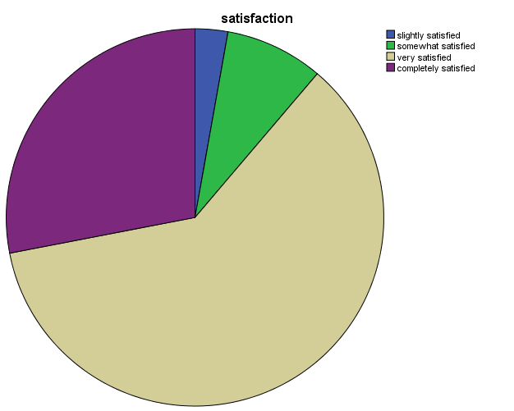

Average satisfaction score 4.14/5.00

Not all satisfied : 0.0%
Slightly satisfied : 2.8%
Somewhat satisfied : 8.4%
Very satisfied : 60.7%
Completely satisfied : 28.0%

CHIANG MAI REVISIT INTENTION

WILLINGNESS TO RECOMMEND CHIANG MAI
Revisit the city in the future | Frequency | Total
Yes | 97 | 90.7%
No | 10 | 9.3%
Total | 107 | 100.0%

Recommendation the city to others | Frequency | Total
Yes | 90 | 84.0%
No | 17 | 16.0%
Total | 107 | 100.0%

What tourist LIKE about Chiang Mai city?

No | Like | Frequency
1 | Foods | 17
 | Friendly People | 10
2 | Night Market | 3
3 | Temple | 3
4 | Culture | 2
5 | Nature | 2
6 | Peaceful | 2
7 | Architecture | 1
8 | Scenery | 1
9 | Shopping | 1
10 | SPA | 1
11 | Heritage | 1

What tourist DISLIKE about Chiang Mai city?

No | Dislike | Frequency
1 | Language Barrier | 1
2 | Crowded | 1
3 | High Price | 1
4 | No Taxi Meter | 1
5 | No Public Bus | 1
6 | Less Rubbish Bin | 1
7 | Cleanliness Eating Places | 1

What are DIFFICULTIES tourists encounter?

No | Difficulties | Frequency
1 | Communication Barrier | 16
2 | Traffic | 1
3 | High Price | 1
4 | Public Transport | 1

References

Discovery Thailand (2016). San Kamphaeng Hot Springs in Chiang Mai. Accessed on Nov 4,
2016,from http://www.discoverythailand.com/Chiang_Mai_San_Kamphaeng_Hot_Springs.asp

Hitchman IT (2016). Sunday Market Chiang Mai. Accessed on Nov 4, 2016 from http://www.embracechiangmai.com/index.php?page=sundaymarketchaingmai

Lonely Planet1 (undated). Wat Pratat Doi Suthep. Accessed on Nov 4, 2016 from https://www.lonelyplanet.com/thailand/chiang-mai/attractions/wat-phra-that-doi-suthep/a/poi-sig/1243262/357655

Lush, E (2016). Bo Sang Umbrella Festival 2016. Accessed on Nov 4, 2016 from http://wander-lush.org/bo-sang-umbrella-festival-2016/

Luxe Adventure Traveler (2016). The Long Neck Karen hill Tribe. Accessed on Nov 4, 2016 from http://luxeadventuretraveler.com/long-neck-karen-hill-tribe/

Maps of World (2016). Accessed on Oct 31, 2016 from http://www.mapsofworld.com/thailand/provinces/chiang-mai-map.html

My Chiang Mai Tour (undated). Doi Pui Hmong Tribal Village: Tribal Village Chiang Mai. Accessed on Nov 4, 2016 from http://mychiangmaitour.com/doipui_hmong/

Radojewski, K (2015). Three Kings Monument and The Museum District of Chiang Mai. Accessed on Nov 8, 2016 from http://www.yaychiangmai.com/editor/1358/kian-radojewski/three-kings-monument-and-the-museum-district-of-chiang-mai

Robinson, G (2012). Tackling tourism in Chiang Mai. Accessed on Nov 4, 2106 from http://www.chiangmaicitylife.com/citylife-articles/tackling-tourism-in-chiang-mai/

Thai Guide to Chiang Mai (2011). Botanical gardens: Queen Sirikit Botanic Garden. Accessed on Nov 4, 2016 from http://www.thaiguidetochiangmai.com/places-of-interest/botanical-gardens-queen-sirikit-botanic-garden/

Tourism Authority of Thailand (2016). Bhubing Rajanives Palace. Accessed on Nov 4, 2016 from http://www.tourismthailand.org/Attraction/Bhubing-Rajanives-Palace--146

Tourism Authority of Thailand1 (undated). Mae Sa Elephant Camp, Chiang Mai. Accessed on Nov 4, 2016 from http://chiangmaispecialist.com/mae-sa-elephant-camp/

Virtual Travel Guides (2010). Chiang Mai night market and bazaar. Accessed on Nov 4, 2016 from http://www.1stopchiangmai.com/shopping/night_market

Wikipedia (2016). Accessed on Oct 31, 2016 from https://en.wikipedia.org/wiki/Tourism_in_Thailand

