TABLE OF CONTENTS

1.0 Introduction of the project…………………………………………………………………………….1
2.0 Background of study site……………………………………………………………………………….2
3.0 Methodology …………………………………………………………………………………………………5
4.0 Analysis……………………....…………………………………………………………………………………6
5.0 References……………………………………………………………………………………………………15

1.0 INTRODUCTION OF THE PROJECT

This project aims to conduct a cross-sectional and longitudinal research on tourism promotion issues of multi-cultural exchanges between four ASEAN countries (Japan, Vietnam, Thailand and Malaysia). Funded by the Japan Foundation Grant of Tourism Research Promotion, this project involves four (4) universities: Kyoto University of Foreign Studies (KUFS) (Japan), Chiang Mai University (CMU) (Thailand), Hanoi University (HANU) (Vietnam) and Universiti Sains Malaysia (USM) (Malaysia).

Kyoto, Hanoi, Chiang Mai and Penang have been chosen as the case studies, which are rich with heritage and cultural elements. Some of these elements have received international recognition and been awarded the World Heritage Site title by the United Nations Educational, Scientific and Cultural Organisation (UNESCO), for example George Town, Penang, Malaysia. The international recognition which attracts high number of visitations hence leads to the importance of understanding factors contributing to tourism development and its longevity. Thus, this project assesses the tourist segmentation, image of the city, tourist motivation and travel satisfaction; from the international tourists perspective.

This project seeks: (i) to understand and evaluate the culture and heritage issues in the selected four cities; (ii) to discover what are the culture and heritage differences between the selected four cities; and (iii) to understand how tourism affects or get affected by culture and heritage.

Self-administered questionnaire survey was undertaken in eleven (11) tourist attractions in Hanoi, namely: Ha Long Bay (a World Heritage Site), Ho Chi Minh Mausoleum, Ho Chi Minh Presidential Place, Ho Chi Minh Museum, One Pillar Pagoda, Museum of Ethnology (venue for water puppet show), Old Quarter, Hanoi Night Market, St. Joseph Cathedral Hanoi, Hang Buom Strret and Noi Bai International Airport. Survey forms were distributed to the international tourists from 8th to 12th September 2016. Of 160, this project has successfully retrieved 141 completed forms. In addition, semi-structured interviews were also performed to a number of international tourists who visited Hanoi during the data collection time frame.

2.0 BACKGROUND OF STUDY SITE

2.1 Overview of Hanoi and Ha Long Bay

Figure 1.0: Hanoi and Ha Long Bay Map
(Source: Vacations To Go Agency, 2016)

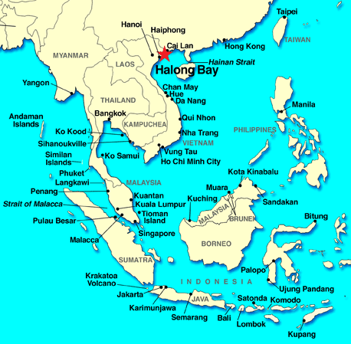

The first study site is the city of Hanoi, Vietnam. It’s the second largest city in Vietnam after Ho Chi Minh City and became the capital of Vietnam when North and South Vietnam reunited in July 1976. Located in the northern region of Vietnam, it plays a role as the heart of the country in economy, politics, culture and its society. Estimated population around 7.2 million in 2012, Hanoi has an area of 927Km², 7 arrondissements, 5 districts and received 3 million international tourists and 14.5 million domestic tourists in 2012 (Nhung, 2008). It has 18% of tourism tourist arrival growth rate yearly. The Hanoi City experiences the typical climate of northern Vietnam, with 4 distinct seasons. Summer from May to August, fall in September to October, winter from November to January and autumn from February to April (Vietnam Online, 2015).
Another site, where the study has been conducted is Ha Long Bay, which located 160 Km from Hanoi. According to UNESCO World Heritage Centre,(2000), “ it's located in the Gulf of Tonkin, within Quang Ninh Province in the northeast of Vietnam, covering an area of 43400 Ha, a home to 1600 islands and islets, uninhabited and unaffected by humans and forming a spectacular seascape of limestone pillars. It has a multitude of limestone islands and islets rising from the sea, in a variety of sizes and shapes”. In 2000, the UNESCO’s World Heritage Committee has inscribed in the World Heritage List according to its outstanding examples representing major stages of the earth’s history and its original limestone geomorphologic features (UNESCO World Heritage Centre, 2000).

History

According to its history, Hanoi was named Thăng Long, means “Ascending Dragon” when the emperor, Ly Thai To in Ly Dynasty claimed to have seen a dragon ascending the Red River back in the year 1010. It was then changed to Đông Đô means ‘Eastern Metropolis’ during Hồ dynasty, later change to Đông Kinh means ‘Eastern Capital’ by Lê dynasty. Hanoi lies on the right bank of the Red River and under the King Minh Mang Dynasty, laid the name Hà Nội on the capital since 1831 means “a city lying between Rivers”, which indicates Red and Day rivers (Logan, 2000). According to United Nations Vietnam (2016), Millennial Anniversary of Hanoi was celebrated from 1 to 10 October 2010, marked the 1,000th anniversary of the foundation of the capital Thăng Long by Emperor Lý Thái Tổ. This makes Hanoi as the antique and dynamic capital of Vietnam that rich with its cultural and heritage.

Hanoian Culture

Hanoian has a betel chewing tradition and tableware of Hanoi betel includes copper tray, silver carving lime tube, lime tube touches and brass spittoons (Vietnam National Administration of Tourism Corporation, 2015). For marriage tradition for Hanoian will start with engagement ceremony. Groom’s family will bring wedding presents to the bride’s family in order to ask for marriage followed by the real wedding ceremony. Hanoian people have a traditional hospitality in respecting guests, teachers and elder generations show high and good morale to younger generations (Nhung, 2008).
Traditional Costumes of Vietnamese people tend to be very simple where men wear brown shirts and white trousers, a long gown with slits on either side, together with a turban made of cotton or silk during formal ceremonies. Whereas, women wear a special three-layered dress called “Ao dai”, a long gown with slits on either side. The outer garment has three layers is called “Au tu Than” (Vietnam National Administration of Tourism Corporation, 2015)

Attractions

According to Nick Ray (2005), The City of Hanoi attractiveness are from the fine combination of natural beauty with ancient colonial architecture and cultural religious features as it has more than 1000 years of history as a capital city of Vietnam. One of the must- see attractions is Tran Quoc Pagoda, one of the oldest pagoda in Vietnam on the eastern shore of West Lake. Has a role of a symbol of Buddhism, the impressive pagoda structures just off the roads that divide West Lake and Truc Bach Lake. Another popular place for recreation for tourist and local residents in Hanoi is urban lake named as West Lake (Hồ Tây) located to the north of Old Quarter.

Visit Hanoi would only be complete with a visit to The Presidential Palace, which is a stilt house and must-see place for tourist. The building was built between 1900 and 1906 to the house of the French Governor-General of Indochina, currently is used for official receptions (Logan, 2000). Ho Chi Minh Mausoleum is another attraction in Hanoi where it is the final resting place of Ho Chi Minh, the most iconic and popular leader of Vietnam. The Buddhist One Pillar Pagoda and Ho Chi Minh Museum located in the same complex with The Presidential Palace and the mausoleum. Hoan Kiem Lake, located south of Old Quarter, known as a lake of the returned sword has scenic marks in the historical centre of ancient Hanoi is another attraction that tourist shouldn’t be missed.

Hanoi Old Quarter is the centre of tourists visiting Hanoi as it is the city’s major commercial district and possesses the ancient streets back in 1000 years and consists of 36 Old streets that sell a diversity of products (Nick Ray, 2005). Next attraction in Hanoi is Vietnam Museum of Ethnology that explain multi-ethnic groups in Vietnam, consists of the virtual indoor tour and outdoor tour, it displays art, 15,000 history artefacts and unique culture of each ethnic. It can be observed during the visit that all the display are well labelled in Vietnamese, French and English.

Situated in the heart of Hanoi, the Central Sector of the Imperial Citadel of Thang Long was listed as UNESCO’s World Heritage Site in 2010. The World Heritage Site comprises two sections: the archaeological site at 18 Hoang Dieu Street and the central axis of the Nguyen Dynasty’s Citadel of Hanoi. The sector are very important to Thang Long Citadel, the capital of Dai Viet under Ly, Tran and Le Dynasties from 11th to the 18th centuries (Nhung, 2008)

3.0 METHODOLOGY

Employing stratified random sampling technique, the survey was conducted either face-to-face interviews with the respondents by enumerators or by self-completion at selected tourist attraction in Hanoi (e.g. Museum Ethnology Hanoi, Ho Chi Minh Mausoleum, Ho Chi Minh Museum) and the gateways to Hanoi namely Hanoi International Airport (Noi Bai) Vietnam. Enumerators screening the respondents at the beginning, to verify that the respondents were a tourist and not the day trippers and transients visitors.

4.0 ANALYSIS

PROFILE OF VISITOR

Gender | Frequency | Total
Male | 56 | 39.7%
Female | 85 | 60.3%
Total | 141 | 100.0%
Age
18-25 years old | 58 | 41.1%
26-35 years old | 64 | 45.4%
36-49 years old | 0 | 0%
≥ 50 years old | 19 | 13.5%
Total | 141 | 100.0%
Marital status
Single | 99 | 70.2%
Married | 39 | 27.7%
Divorce/widowed | 3 | 2.1%
Total | 141 | 100.0%
Highest Level of Education
Higher Degree – Master/PhD | 49 | 35.3%
Tertiary Education-Diploma/Degree | 73 | 52.5%
Secondary/High School Education | 13 | 9.2%
Primary/Elementary Education | 2 | 1.4%
No Formal Education | 2 | 1.4%
Total | 141 | 100.0%

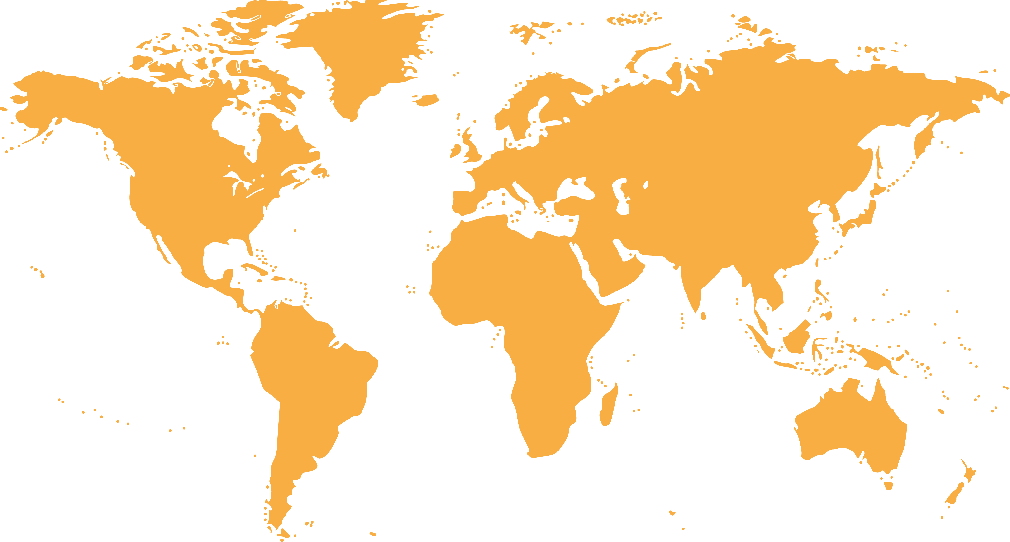

13.5%
Eastern
Asia

15.6%
Oceania

18.4%
Southeast
Asia

2.8%
Southern
Asia

5.0%
Africa

2.8%
Western
Asia

27.7%
Europe

14.2%
Americas

Country of residence | Frequency | Total
Southeast Asia | 26 | 18.4%
Western Asia | 4 | 2.8%
Eastern Asia | 19 | 13.5%
Oceania | 22 | 15.6%
Europe | 39 | 27.7%
Americas | 20 | 14.2%
Sothern Asia | 4 | 2.8%
Africa | 7 | 5.0%
Total | 141 | 100%

IMAGES OF HANOI

The majority of visitors perceived the images of Hanoi as:

1. Local Cuisine
2. World Heritage Site
3. Traditional

Image of Hanoi | Frequency | Total
World Heritage Site | 33 | 23.4%
Local Cuisine | 47 | 33.3%
Sandy Beaches | 3 | 2.1%
Healthcare Destination | 2 | 1.4%
Shopping Paradise | 7 | 5.0%
Nightlife Entertainment | 4 | 2.8%
Modern City Life | 9 | 6.4%
Safe Destination | 4 | 2.8%
Multicultural society | 4 | 2.8%
Hills/jungles/green | 4 | 2.8%
International events | 3 | 2.1%
Cultural Performance | 1 | 0.7%
Education Hub | 7 | 5.0%
Traditional | 13 | 9.2%
Total | 141 | 100.0%

FACTORS INFLUENCED VISITOR’S DECISION TO TRAVEL

Statement | Not Influential at all | A little bit Influential | Somewhat influential | Influential | Very Influential | Total
Positive Image | 12.1% | 5.0% | 28.6% | 34.3% | 20.0% | 100%
Heritage sites, culture, arts and tradition | 2.8% | 3.5% | 18.4% | 44.0% | 31.2% | 100%
Friendliness of local people | 5.0% | 7.8% | 31.2% | 36.9% | 19.1% | 100%
Safety level of destination | 9.9% | 16.3% | 25.5% | 29.1% | 19.1% | 100%
Convenience of Visa | 19.1% | 13.5% | 27.7% | 25.5% | 14.2% | 100%
Affordability of the destination | 2.8% | 6.4% | 23.4% | 31.9% | 35.5% | 100%
Urban landscape | 9.9% | 17.0% | 28.4% | 24.8% | 19.9% | 100%
Food | 5.7% | 3.5% | 24.1% | 27.0% | 39.7% | 100%
Natural scenery | 6.4% | 7.8% | 24.1% | 27.0% | 34.8% | 100%
Geographically close | 24.1% | 11.3% | 31.9% | 19.9% | 12.8% | 100%
Climate | 8.5% | 21.3% | 36.2% | 24.1% | 9.9% | 100%
Hygiene level | 18.4% | 22.7% | 34.8% | 15.6% | 8.5% | 100%
Beautiful beaches | 18.4% | 14.2% | 34.8% | 18.4% | 14.2% | 100%
Shopping experience | 23.4 | 17.7% | 31.2% | 19.9% | 7.8% | 100%
Festival and events | 11.3% | 17.0% | 34.0% | 27.0% | 10.6% | 100%
Nightlife | 14.9% | 22.7% | 34.0% | 21.3% | 7.1% | 100%
Outdoor activities | 7.1% | 14.9% | 24.8% | 34.0% | 19.1% | 100%
Level of ICT infrastructure | 14.9% | 19.1% | 44.4% | 19.9% | 2.1% | 100%
Status of destination (e.g. world heritage) | 9.9% | 12.8% | 31.2% | 26.2% | 19.9% | 100%
Interesting amusement/theme parks | 29.1% | 22.0% | 27.0% | 16.3% | 5.7% | 100%
Similarity of culture | 41.1% | 17.7% | 23.4% | 14.9% | 2.8% | 100%
Same religion | 59.6% | 12.1% | 20.6% | 5.7% | 2.1% | 100%
Statement | Not Applicable | Poor | Below Average | Average | Good | Excellent
Hospitality of immigration officials at the entrance point | 0.7% | 8.5% | 14.9% | 39.6% | 27.7% | 10.6%
Check in/check-out process at the airport | 0% | 2.8% | 7.8% | 40.4% | 31.2% | 17.7%
Availability of information at entry points | 2.1% | 7.8% | 14.9% | 31.9% | 29.1% | 14.2%
Local public transport services | 10.6% | 8.5% | 12.8% | 37.6% | 20.6% | 9.9%
Accessibility of tourist attractions | 1.4% | 1.4% | 7.1% | 30.5% | 41.1% | 18.4%
Prices of local public transportation | 7.1% | 6.4% | 3.5% | 22.0% | 36.9% | 24.1%
Availability of accommodation | 0% | 0.7% | 4.3% | 17.7% | 39.0% | 38.3%
Quality of accommodation | 0.7% | 0% | 1.4% | 14.9% | 31.9% | 51.1%
Hospitality of hotel staff | 0% | 0.7% | 1.4% | 14.9% | 31.9% | 51.1%
Price of accommodation | 0.7% | 1.4% | 0.7% | 21.4% | 40.7% | 35.0%
Internet connectivity/WIFI | 2.1% | 4.3% | 3.5% | 19.9% | 41.8% | 28.4%
Money changer/automatic teller machine (ATM) | 10.6% | 2.1% | 3.5% | 36.2% | 34.0% | 13.5%
Shopping facilities | 3.5% | 3.5% | 12.1% | 34.0% | 31.2% | 15.6%
Public toilets | 7.1% | 18.4% | 18.4% | 32.6% | 17.0% | 6.4%
Signage at attraction | 7.1% | 4.3% | 17.7% | 39.0% | 26.2% | 5.7%
Tourist information centre | 8.5% | 3.5% | 15.6% | 41.1%% | 25.5% | 5.7%
The price of goods | 0.7% | 2.1% | 8.5% | 29.1% | 35.5% | 24.1%
Variety of tourist attraction | 0.7% | 2.1% | 8.5% | 32.6% | 33.3% | 22.7%
Nightlife entertainment | 7.1% | 2.8% | 12.1% | 41.1% | 29.1% | 7.8%
Cleanliness of beaches and ocean | 9.2% | 7.8% | 13.5% | 39.7% | 20.6% | 9.2%
Price of food and beverages | 1.4% | 2.1% | 9.9% | 28.4% | 29.1% | 29.1%
Cleanliness of eating places | 2.8% | 6.4% | 22.7% | 33.3% | 27.0% | 7.8%

HANOI TRAVEL SATISFACTION

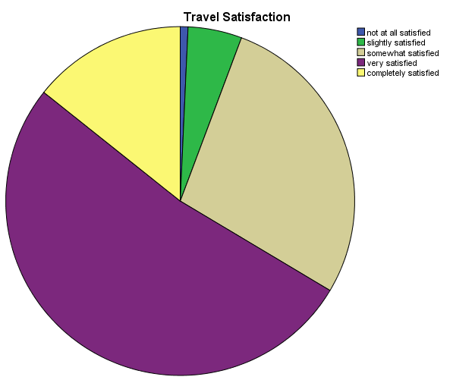

Average satisfaction score 3.74/5.00

Not all satisfied : 0.7%
Slightly satisfied : 5.0%
Somewhat satisfied : 27.9%
Very satisfied : 52.1%
Completely satisfied : 14.3%

HANOI REVISIT INTENTION

WILLINGNESS TO RECOMMEND HANOI
Revisit the city in the future | Frequency | Total
Yes | 106 | 75.2%
No | 35 | 24.8%
Total | 141 | 100.0%

Recommendation the city to others | Frequency | Total
Yes | 91 | 64.1%
No | 50 | 35.9%
Total | 141 | 100.0%

What tourist LIKE about Hanoi city?

No | Like | Frequency
1 | Friendly People | 22
2 | Cuisine | 22
3 | Vibrant City | 11
4 | Nature | 8
5 | Culture | 5
6 | Cheap Price | 5
7 | Nightlife | 5
8 | Hospitality | 5
9 | History | 4
10 | Shopping | 3
11 | Safe Place | 1

What tourist DISLIKE about Hanoi city?

No | Dislike | Frequency
1 | Traffic Congestion | 19
2 | Dirty | 18
3 | Noisy | 10
4 | Price Discrimination | 4
5 | Crowded | 4
6 | Dangerous Drive | 4
7 | Food | 2
8 | Weather | 2
9 | No Rubbish Bin | 1
10 | Communication barrier | 1

What are DIFFICULTIES tourists encounter?

No | Difficulties | Frequency
1 | Communication Barrier | 26
2 | Safety of Pedestrian | 14
3 | Taxi Driver Scam | 8
4 | Lack of Signage | 7
5 | Price Discrimination | 4
6 | Poor Public Transportation System | 4
7 | Hygiene | 2
8 | Too Many Bikes | 2
9 | Stealing Case | 2
10 | Hard to Find Halal Food | 2
11 | Lack of Money Changes | 2
12 | Visa Application | 1
13 | Corruption in Immigration | 1
14 | Lack of Parking Area | 1
15 | Hostile Behaviour from Old Local People | 1
16 | No wifi access | 1
17 | Noise | 1
18 | Lack of tourism information | 1
19 | Car and Motorcycle Horns | 1

References

Inter Asia Group Tour. (2016). Retrieved on October 11,2016, from Inter Asia Website: http://www.interasia.com.au
Logan, W. S. (2000). Hanoi: Biography of the City. Australia: University of New Sout Wales Press Ltd.
Nhung, T. (2008, July 10). Hanoi-the antique and dynamic capital of Vietnam. Retrieved from Vietnam-Beauty Web site: http://www.vietnam-beauty.com
Nick Ray, W. Y. (2005). Vietnam. USA: Lonely Planet Publications Pty. Ltd.
UNESCO World Heritage Centre. (2000). Retrieved on October 10,2016, from UNESCO World Heritage Centre Web site: http://whc.unesco.org/
United Nations Vietnam. (2016). Retrieved on October 6,2016, from United Nations Vietnam Web site: http://www.un.org.vn
Vacations To Go Agency. (2016). Retrieved on October 6,2016, from Vacations To Go Web site: www.vacationstogo.com
Vietnam National Administration of Tourism Corporation. (2015). Retrieved on October 6,2016, from Vienam Country and People: Vietnam Tourism Web site: http://www.vietnamtourism.com/
Vietnam Online. (2015). Retrieved on October 6,2016, from Vietnam Weather :Vietnam Online Corporation Web Site: https://www.vietnamonline.com

