TABLE OF CONTENTS

1.0 Introduction of the project…………………………………………………………………………….1
2.0 Background of study site……………………………………………………………………………….2
3.0 Methodology …………………………………………………………………………………………………6
4.0 Analysis……………………....…………………………………………………………………………………7
5.0 References……………………………………………………………………………………………………16

1.0 INTRODUCTION OF THE PROJECT

This project aims to conduct a cross-sectional and longitudinal research on tourism promotion issues of multi-cultural exchanges between four ASEAN countries (Japan, Vietnam, Thailand and Malaysia). Funded by the Japan Foundation Grant of Tourism Research Promotion, this project involves four (4) universities: Kyoto University of Foreign Studies (KUFS) (Japan), Chiang Mai University (CMU) (Thailand), Hanoi University (HANU) (Vietnam) and Universiti Sains Malaysia (USM) (Malaysia).

Kyoto, Hanoi, Chiang Mai and Penang have been chosen as the case studies, which are rich with heritage and cultural elements. Some of these elements have received international recognition and been awarded the World Heritage Site title by the United Nations Educational, Scientific and Cultural Organisation (UNESCO), for example George Town, Penang, Malaysia. The international recognition which attracts high number of visitations hence leads to the importance of understanding factors contributing to tourism development and its longevity. Thus, this project assesses the tourist segmentation, image of the city, tourist motivation and travel satisfaction; from the international tourist’s perspective.

This project seeks: (i) to understand and evaluate the culture and heritage issues in the selected four cities; (ii) to discover what are the culture and heritage differences between the selected four cities; and (iii) to understand how tourism affects or get affected by culture and heritage.

Self-administered questionnaire survey was undertaken in eight (8) tourist attractions in Kyoto, namely: Kinkakuji Temple, Rock Garden, Nishiki Street Food Market, Nijo Castle, Toji Temple, Kiyomizu, Teramachi and Arashiyama. Survey forms were distributed to the international tourists from 14th to 20th October 2016. Of 120 this project has successfully retrieved 98 completed forms.

2.0 BACKGROUND OF STUDY SITE

Kyoto is an ancient city with a 1200-year history. It is Japan's third largest city and also one it’s oldest. It was originally founded as Heian kyo in 794 (Nara Period) and had its golden age during its heydey from 794 to 1185. Throughout the centuries, Kyoto has many functions in the crossroads of Japanese history. Being the capital of Japan for over 1000 years, today’s Kyoto is the cultural centre of Japan and continues to be loved by Japanese and people of the world alike.
This ancient capital of Japan, whose traditions have been matured through the ages, is now making startling advancements. Kyoto also conserves the treasured properties of its culture as testimonials of time. This is shown in the ancient temples and shrines built in styles unique to Kyoto, as well as private houses. Surviving the hardships of World War II, present-day Kyoto advanced in many significant ways. Now, new leading industries and scientific institutions make important contributions around the world, and many precious cultural properties of the past are preserved here (The Kyoto Prefecture Government, 2016).
The world heritage status gained by 17 historical sites located in the city had attracted million visitors to visit and enjoy this ancient city, which continues cherishing its culture and heritage. Among popular world heritage sites found in Kyoto are the famous Kiyomizu temple, the Kinkaku Ji, and the Ryoan Ji, to name a few. Kyoto was named in 2014 by the US-based magazine Travel + Leisure to be the world’s best city which attracted some over 50 million visitors every year. Nearly half of them come from North America, Oceania, neighbouring Asia, and Europe (Iuchi, 2014). Recent development saw the rapid growth of Chinese visitors from Mainland China, which changes the landscape of the tourism businesses of Kyoto.

The geographical background

This city of almost 1.5 million people is located in the Kansai region of Japan (Figure 1 and Figure 2). It is a part of the greater megapolis of Osaka-Kyoto. This city is accessible via the Kansai International Airport as well as via highways and railway lines from its central station. It extended 5.2km. from north to south, and 4.7km. from east to west. On either side of the main road, Suzaku-Oji (85m. wide), were areas called Sakyo and Ukyo. The Government was directly managing the manufacture of many handicrafts, and craftsmen who practised the most advanced techniques of the time also gathered to live here (Kyoto Prefecture Government, 2016).

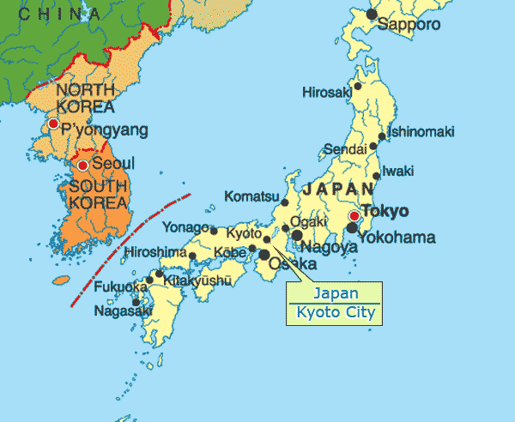
Figure 1: Figure 1: Location of Kyoto Justmaps.org. 2016

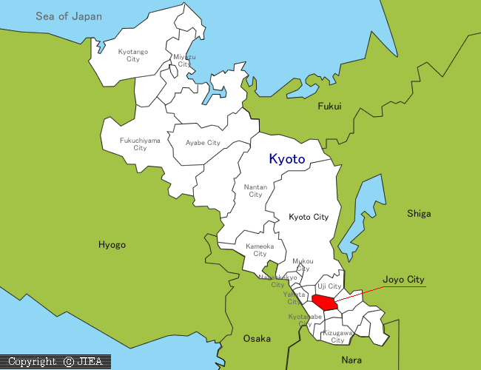
Figure 2: The Kyoto Prefecture (Source: JIEA, 2016)

Government offices and the house of the Emperor were located in Dai-dairi, in the northern part of Heian-Kyo. It was the political centre of the nation where nobles, officers and soldiers, as well as the Emperor himself, worked. The surrounding area consisted mainly of the administrative offices, located on the neatly arranged streets (Kyoto Prefecture Government, 2016). From the middle of the 10th century, the city gradually began to undergo change. Ukyo became less metropolitan, reverting back to a low-populated rural area of fields and gardens. Residents began to concentrate in the Sakyo area, and Heian-Kyo mainly developed to the east of the Kamo River beyond the city proper, and also into the north. This city was later redesigned and named Kyoto around the 11th or 12th century. Throughout the 13th and 15th centuries, construction continued on, changing the cityscape of Kyoto and giving it new character as a city with a strong religious culture. This city plan remained for about one century until Toyotomi Hideyoshi ordered the city to be completely rebuilt. He filled up the space between Kamigyo and Shimogyo to promote urbanisation, and again gave Kyoto the look of an integrated city. For the first time, an earthen embankment enclosed Kyoto. The Gosho (Imperial Palace), was reconstructed in the centre of the city, and the newly built Juraku-dai Castle shined proudly in gold (Kyoto Prefecture Government, 2016).

During this revolution, the citizens of medieval Kyoto became industrially active. The downfall of the national industry forced the merchants and craftsmen (which include the making of Kimono, and other religious items), who had been working for Government-managed industries to become independent. They organised themselves into "za" or cooperative associations, which protected the rights and interests of their businesses, and in turn made industry and the economy more dynamic than ever before (Kyoto Prefecture Government, 2016).
This ' za(s)’ get together every year in their locality to organise and celebrate various matsuri(s) or fiestas. Main festivals include the Gion fest, originated during the outbreak of a pestilence in 869, when the people prayed to the deity of Gion - jinja Shrine, Susano-onomikoto, to rid the land of the pestilence (Kyoto prefecture government, 2016).

Traditional skills

Home to many cultural landmarks, Kyoto is thought of as the heart of Japan. For most of Japan's history, Heian was the centre not only of government but also of learning and the arts (Columbia education, 2016). Traditional skills developed more than 1000 years in this ancient capital are now being utilised in cutting-edge technologies. Furthermore, the people of Kyoto have produced many religious arts and forms of entertainment. Countless religious Shinto rituals and festivals have captured the imagination of people the world over.
The Toyotomi rule revived temples and shrines considerably, and under the Tokugawa rule, which followed, Kyoto regained its honour as a city of religion and culture. Revitalization as an industrial city was even more remarkable. At the end of the 17th century, Nishijin became one of the most renowned textile districts in the world. Hein’s site was chosen for its easy river and road access, auspicious topography, and strategic mountain and river defences. Mount Hiei is the most prominent of the mountains around Heiankyo, 848 meters high. An object of mountain worship in ancient times, it became the main centre of Buddhism when temples were erected there to guard the northeast direction of the capital(Columbia education, 2016).

The markets of Kyoto

Kyoto is famous for its covered markets. Many are located near the transportation hub. Two areas were officially set aside for markets in Kyoto, one in either half of the city. They were accordingly called the East and West Markets. In the early years, the East market would be open for the first fifteen days of each month, on an alternating schedule with the West Market. With the decline of the Ukyo district in the southwestern part of the city, the West Market soon ceased to be used. Efforts to revive it included limiting the sale of certain goods to the West Market and the establishment of the public financial institution there, but it eventually closed in the middle. (Columbia education, 2016). Teramachi-dori is one of the most famous streets in Kyoto city. This street has a variety of characteristics and a calm ambience. There are many good stores from south of Kyoto City Hall to the north of the centre of Kyoto. These stores can be both tasteful and traditional, but on the other hand, there is also a number that offers modern styling for Japanese people. There are many stores selling all kinds of items from comics to rice bowls. We are sure you can get a feel for the Japanese mind and culture through them. There are also many kinds of restaurants for the food lovers to enjoy. For example, there are traditional and modern Japanese restaurants, coffee shops, Italian and Indian restaurants, and much more (Tanaka & Matsui, 2014).

3.0 METHODOLOGY

Employing stratified random sampling technique, the survey was conducted either face-to-face interviews with the respondents by enumerators or by self-completion at selected tourist attraction in Hanoi (e.g. Kinkakuji temple, Rock Garden, Nishiki Street food market, Nijo Castle, Toji Temple, Kiyomizu, Teramachi and Arashiyama). Enumerators screening the respondents at the beginning, to verify that the respondents were a tourist and not the day trippers and transients visitors.

4.0 ANALYSIS

PROFILE OF VISITOR

Gender | Frequency | Total
Male | 41 | 41.8%
Female | 57 | 58.2%
Total | 98 | 100.0%
Age
18-25 years old | 22 | 22.4%
26-35 years old | 49 | 50.0%
36-49 years old | 15 | 15.3%
≥ 50 years old | 12 | 12.2%
Total | 98 | 100.0%
Marital status
Single | 57 | 58.2%
Married | 40 | 40.8%
Divorce/widowed | 1 | 1.0%
Total | 98 | 100.0%
Highest Level of Education
Higher Degree – Master/PhD | 33 | 33.7%
Tertiary Education-Diploma/Degree | 51 | 52.0%
Secondary/High School Education | 13 | 14.3%
Primary/Elementary Education | 14 | 0.0%
No Formal Education | 0 | 0.0%
Total | 98 | 100.0%

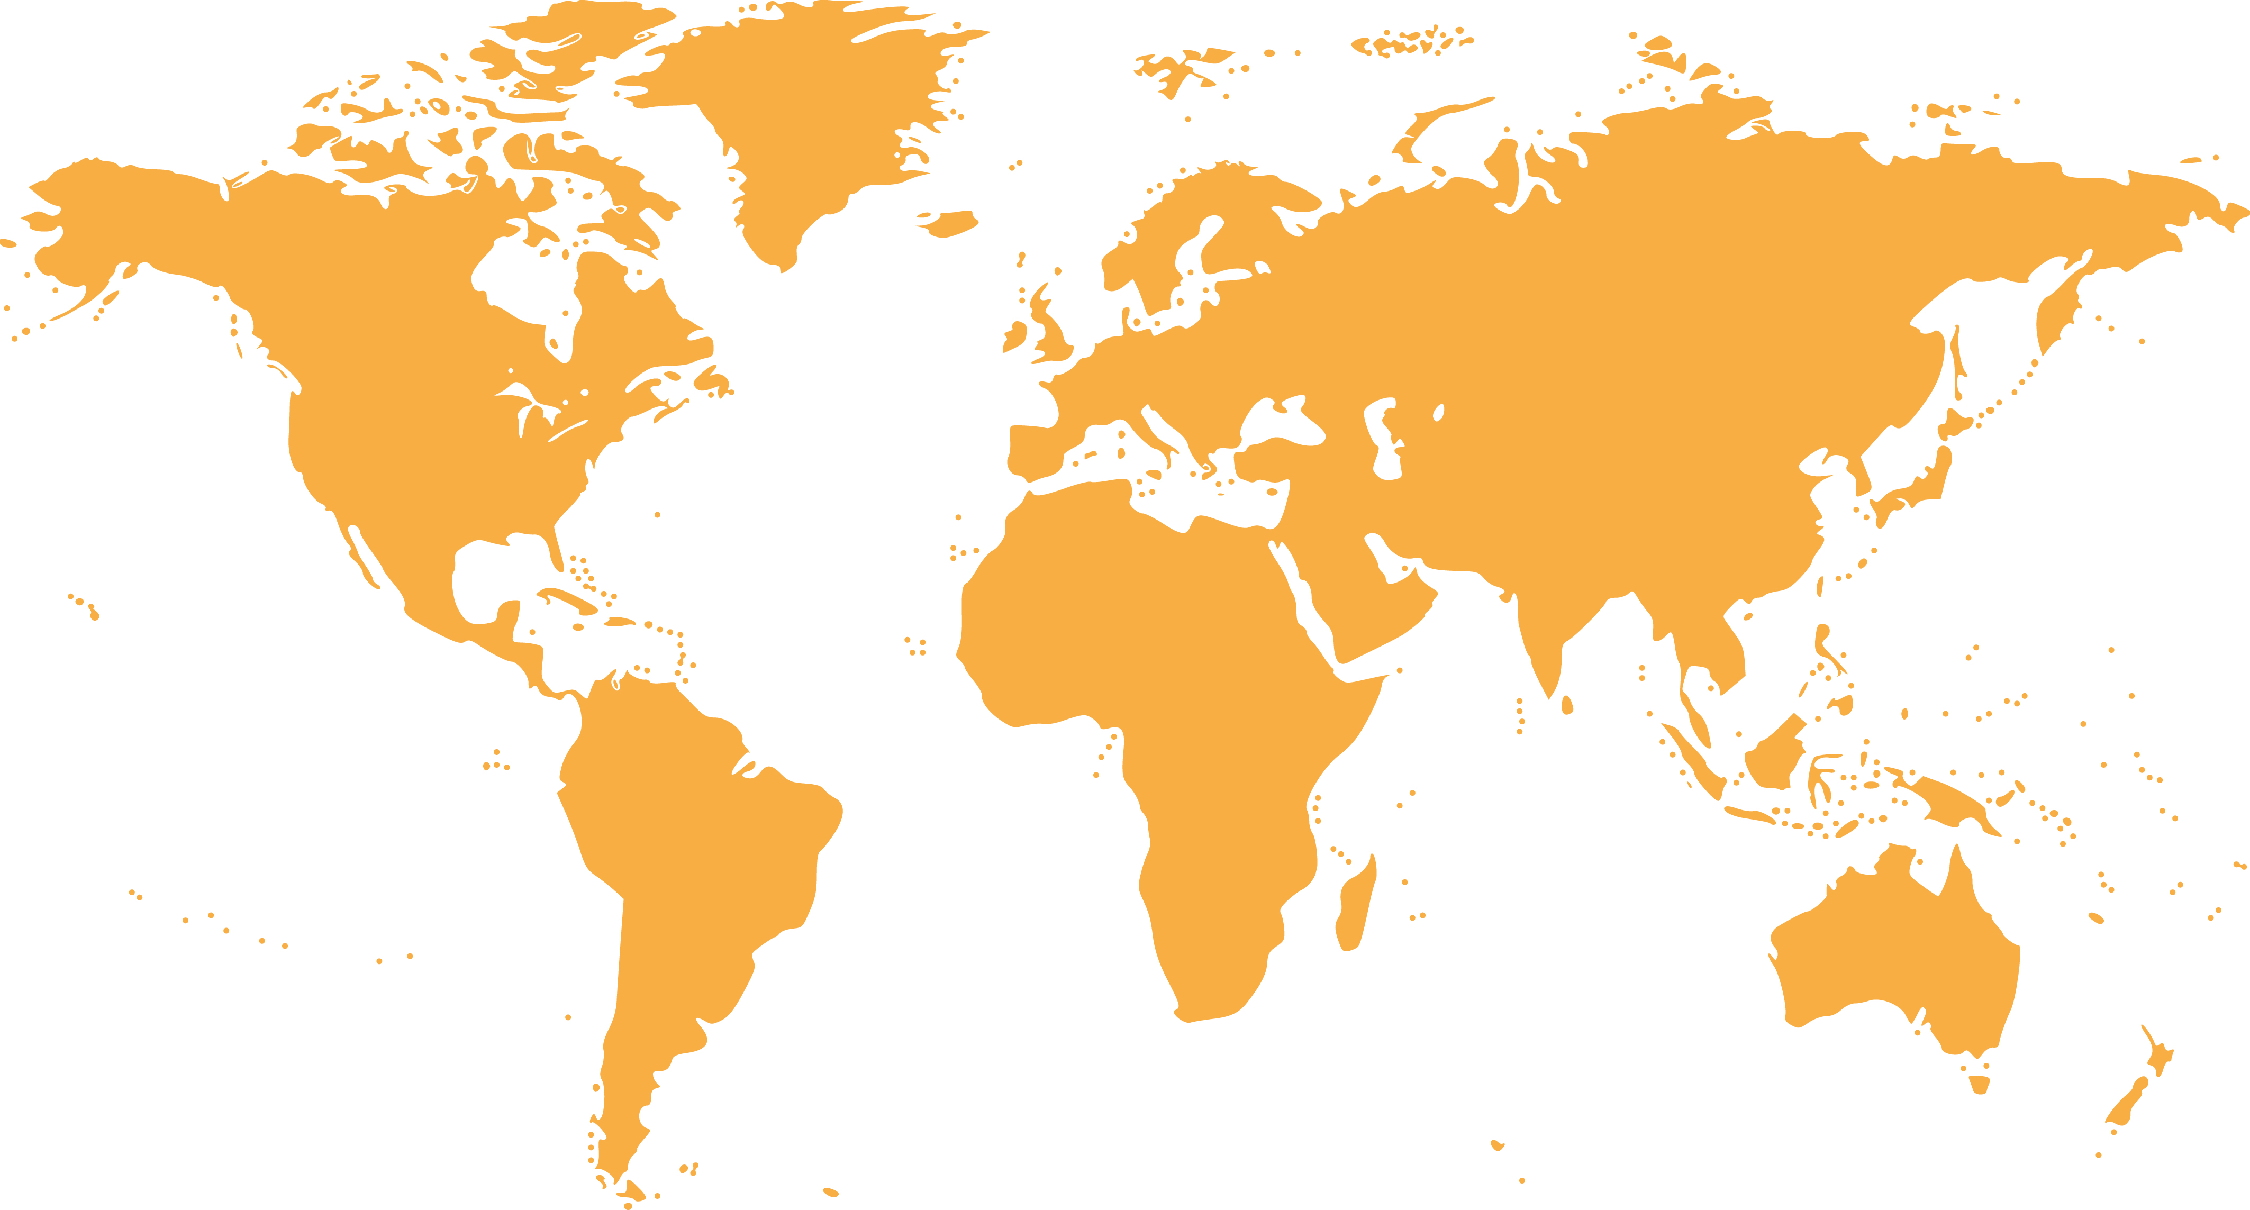

19.4%
Eastern
Asia

8.2%
Oceania

26.5%
Southeast
Asia

1.0%
Southern
Asia

1.0%
Africa

7.1%
Western
Asia

17.3%
Europe

19.4%
Americas

Country of residence | Frequency | Total
Southeast Asia | 26 | 26.5%
Western Asia | 7 | 7.1%
Eastern Asia | 19 | 19.4%
Oceania | 8 | 8.2%
Europe | 17 | 17.3%
Americas | 19 | 19.4%
Sothern Asia | 1 | 1.0%
Africa | 1 | 1.0%
Total | 98 | 100%

MAIN PURPOSES OF TRAVEL

1. Leisure
2. Culture and heritage
3. Education
4. Shopping
5. Visit friends/relatives (VFR)/ back to hometown

Main Purpose of Travel | Frequency | Total
Leisure/recreation | 68 | 69.4%
Culture and heritage | 13 | 13.3%
Education/teaching/training | 0 | 7.1%
Shopping | 4 | 4.1%
Visit friends/relatives (VFR)/back to hometown | 3 | 3.1%
Business/meeting | 0 | 0.0%
Health treatment | 0 | 0.0%
Convention/conference/trade show/ exhibition | 0 | 0.0%
Religious/pilgrimages | 0 | 0.0%
Sporting | 0 | 0.0%
Others | 0 | 0.0%
Total | 98 | 100.0%

IMAGES OF KYOTO

The majority of visitors perceived the images of Hanoi as:

1. World Heritage Site
2. Local Cuisine
3. Safe Destination

Image of Kyoto | Frequency | Total
World Heritage Site | 69 | 48.3%
Local Cuisine | 20 | 14.0%
Safe Destination | 16 | 11.2%
Hills/jungles/green | 9 | 6.3%
Multicultural society | 6 | 4.2%
Sandy Beaches | 1 | 0.7%
Nightlife Entertainment | 5 | 3.5%
Modern City Life | 5 | 3.5%
Shopping Paradise | 4 | 2.8%
Education Hub | 3 | 2.1%
International events | 2 | 1.4%
Cultural Performance | 2 | 1.4%
Traditional | 1 | 0.7%
Healthcare Destination | 0 | 0.0%
Total | 98 | 100.0%

FACTORS INFLUENCED VISITOR’S DECISION TO TRAVEL

Statement | Not Influential at all | A little bit Influential | Somewhat influential | Influential | Very Influential | Total
Positive Image | 1.0% | 2.0% | 9.2% | 35.7% | 52.0% | 100%
Heritage sites, culture, arts and tradition | 1.0% | 3.1% | 7.1% | 29.6% | 59.2% | 100%
Friendliness of local people | 2.0% | 4.1% | 13.3% | 45.9% | 34.7% | 100%
Safety level of destination | 3.1% | 3.1% | 12.2% | 24.5% | 57.1% | 100%
Convenience of Visa | 14.3% | 6.1% | 11.2% | 26.5% | 41.8% | 100%
Affordability of the destination | 12.2% | 13.3% | 18.4% | 33.7% | 22.4% | 100%
Urban landscape | 3.1% | 5.1% | 27.6% | 29.6% | 34.7% | 100%
Food | 1.0% | 4.1% | 14.3% | 30.6% | 50.0% | 100%
Natural scenery | 2.0% | 2.0% | 5.1% | 24.5% | 66.3% | 100%
Geographically close | 20.4% | 9.2% | 20.4% | 21.4% | 28.6% | 100%
Climate | 13.3% | 3.1% | 21.4% | 30.6% | 31.6% | 100%
Hygiene level | 6.1% | 5.1% | 15.3% | 32.7% | 40.8% | 100%
Beautiful beaches | 27.6% | 13.3% | 17.3% | 19.4% | 22.4% | 100%
Shopping experience | 19.4% | 19.4% | 14.3% | 19.4% | 27.6% | 100%
Festival and events | 10.2% | 13.3% | 24.5% | 21.4% | 30.6% | 100%
Nightlife | 20.4% | 23.5% | 18.4% | 19.4% | 18.4% | 100%
Outdoor activities | 7.1% | 10.2% | 23.5% | 30.6% | 28.6% | 100%
Level of ICT infrastructure | 8.2% | 9.2% | 31.6% | 21.4% | 29.6% | 100%
Status of destination (e.g. world heritage) | 6.1% | 4.1% | 19.4% | 27.6% | 42.9% | 100%
Interesting amusement/theme parks | 20.4% | 15.3% | 17.3% | 20.4% | 26.5% | 100%
Similarity of culture | 31.6% | 16.3% | 18.4% | 16.3% | 17.3% | 100%
Same religion | 45.9% | 11.2% | 20.4% | 9.2% | 13.3% | 100%
Statement | Not Applicable | Poor | Below Average | Average | Good | Excellent
Hospitality of immigration officials at the entrance point | 4.1% | 0.0% | 6.1% | 14.3% | 30.6% | 44.9%
Check in/check-out process at the airport | 5.1% | 0.0% | 2.0% | 14.3% | 38.8% | 39.8%
Availability of information at entry points | 2.0% | 0.0% | 3.1% | 21.4% | 36.7% | 36.7%
Local public transport services | 2.0% | 0.0% | 2.0% | 8.2% | 35.7% | 52.0%
Accessibility of tourist attractions | 1.0% | 0.0% | 2.0% | 15.3% | 36.7% | 44.9%
Prices of local public transportation | 4.1% | 5.1% | 15.3% | 25.5% | 24.5% | 25.5%
Availability of accommodation | 4.1% | 2.0% | 4.1% | 25.5% | 29.6% | 34.7%
Quality of accommodation | 1.0% | 0.0% | 3.1% | 18.4% | 35.7% | 41.8%
Hospitality of hotel staff | 8.2% | 0.0% | 4.1% | 10.2% | 29.6% | 48.0%
Price of accommodation | 2.0% | 5.1% | 13.3% | 36.7% | 19.4% | 23.5%
Internet connectivity/WIFI | 6.1% | 0.0% | 10.2% | 16.3% | 26.5% | 40.8%
Money changer/automatic teller machine (ATM) | 11.2% | 1.0% | 4.1% | 25.5% | 29.6% | 28.6%
Shopping facilities | 3.1% | 0.0% | 5.1% | 16.3% | 39.8% | 35.7%
Public toilets | 2.0% | 0.0% | 3.1% | 17.3% | 36.7% | 40.8%
Signage at attraction | 2.0% | 1.0% | 4.1% | 21.4% | 32.7% | 38.8%
Tourist information centre | 6.1% | 0.0% | 6.1% | 23.5% | 26.5% | 37.8%
The price of goods | 1.0% | 2.0% | 13.3% | 39.8% | 26.5% | 17.3%
Variety of tourist attraction | 3.1% | 0.0% | 0.0% | 13.3% | 49.0% | 34.7%
Nightlife entertainment | 11.2% | 2.0% | 9.2% | 32.7% | 24.5% | 20.4%
Cleanliness of beaches and ocean | 27.6% | 0.0% | 6.1% | 11.2% | 30.6% | 24.5%
Price of food and beverages | 3.1% | 1.0% | 7.1% | 34.7% | 32.7% | 21.4%
Cleanliness of eating places | 1.0% | 0.0% | 0.0% | 10.2% | 35.7% | 53.1%

KYOTO TRAVEL SATISFACTION
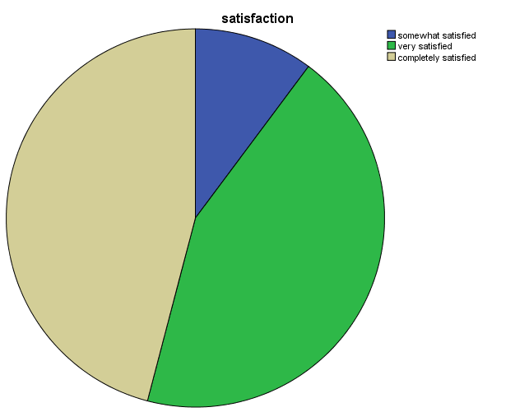

Average satisfaction score 4.36/5.00

Not all satisfied : 0.0%
Slightly satisfied : 0.0%
Somewhat satisfied : 10.2%
Very satisfied : 43.9%
Completely satisfied : 45.9%

KYOTO REVISIT INTENTION

WILLINGNESS TO RECOMMEND KYOTO
Revisit the city in the future | Frequency | Total
Yes | 93 | 95.9%
No | 5 | 4.1%
Total | 98 | 100.0%

Recommendation the city to others | Frequency | Total
Yes | 85 | 86.7%
No | 13 | 13.3%
Total | 98 | 100.0%

What tourist LIKE about Kyoto city?

No | Like | Frequency
1 | Friendly People | 12
2 | Cleanliness | 9
3 | Beautiful City | 5
4 | Culture | 5
5 | Weather | 4
6 | Peaceful | 2
7 | Foods | 2
8 | Heritage | 2
9 | Public Transport | 2
10 | Accessible | 1
11 | Respective | 1

What tourist DISLIKE about Kyoto city?

No | Dislike | Frequency
1 | Language Barrier | 5
2 | Crowded | 5
3 | High Price | 2
4 | Signage confusion | 1
5 | No Wifi | 1
6 | No Rubbish Bin | 1

What are DIFFICULTIES tourists encounter?

No | Difficulties | Frequency
1 | Communication Barrier | 16
2 | No Trash bin | 2
3 | High Price | 1
4 | Bus Services | 1

References

Columbia Education (2016) About Kyoto, available at www.columbia.edu, accessible on 17 November 2016.

Iuchi, C. (2014) Mayor of Kyoto has big plans for tourism. Japan Times, 12 September 2014. Available at www.japantimes.co.jp. Accessed on 6 December 2016.

Kyoto City (2016) Kyoto City Web, available at www2.city.kyoto.lg.jp. accessed on 6 December 2016.

Kyoto Prefecture Government (2016) Welcome to Kyoto, available at http://www.pref.kyoto.jp/ accessed on 7 December 2016.

Shiho Tanaka and Keita Matsui (2014) Teramachi-dori (Teramachi Street), available at thekyotoproject.org accessible on 5 November 2016

Appendix 1

Japan Foundation ASEAN-Japan Tourism Exchange Project

Kyoto Schedule

Oct 15th: Penang teams arrive and will check-in at the hotel in the morning.

Oct 16th: Hanoi team arrive and check-in to hotel.

Students spend day out with Japanese students, and teachers attend TEDx .

Welcome dinner together as a group in the evening at Gaidai (buffet style/Cafe Taro) from 6.00 pm

Oct 17th (Day One):

9.00 - 11.00 – Everyone meets at Gaidai and host group leaders and research directors explain the day’s activities. Students split into groups and discuss the activities to come, check maps and routes and transport details, survey sheets, etc)

10.30 - 2.00 - student groups depart to conduct survey No 1 at 5 World Heritage sites in Kyoto City (ex: Kinkakuji, Toji Temple, Kiyomizu, Nijo Castle, Shimogamo Shrine)

2.00 - 6.00 - All members proceed directly to workshop event with Shogo Kobashi' s father and grandfather, who are leading obi embroiders, at their studio in Kyoto.

Oct 18th (Day Two):

9.00 - 12.00 - groups meet at Gaidai and start work on their research data and presentations of the Day One activities with teachers.

12.00 - 1.00 - Lunch on campus

1.00– 5.00 - Students go to Toho Movie Studio in Uzumasa to research Japanese traditional and popular culture

1.15 – 2.45 - teachers have presentation/discussion with Professor Jeff Berglund (Kyoto City International Ambassador)

3.00 – 5.00 – teachers have presentation/workshop on the Kyoto Project Website with professor Aaron Campbell

Oct 19th (Day Three):

9.00 - 11.00 - groups meet at Gaidai and host group leaders and research directors explain the day’s activities, and have a presentation/workshop from an expert on Japanese food.

11.00 - 3.00 - student groups depart to visit Nishiki Street food market and the Teramachi, Shinkyogoku, Kawaramachi area to conduct survey No 2 on food and commercial tourism.

3.00 - 4.30 - student groups return to university and finalize their short presentations

Teachers meet with invited guests from MICE, etc, to discuss tourism issues in a short symposium style gathering

5.00 – 6.00 Each student group gives a short powerpoint presentation on their activities/findings.

6.00 – 8.00 – Farewell dinner (buffet style).

Oct 20th – Departure of visitors

