TABLE OF CONTENTS

1.0 Introduction of the project…………………………………………………………………………….1
2.0 Background of study site……………………………………………………………………………….2
3.0 Methodology …………………………………………………………………………………………………7
4.0 Analysis…………………… ...…………………………………………………………………………………8
5.0 References……………………………………………………………………………………………………17

1.0 INTRODUCTION OF THE PROJECT

This project aims to conduct a cross-sectional and longitudinal research on tourism promotion issues of multi-cultural exchanges between four ASEAN countries (Japan, Vietnam, Thailand and Malaysia). Funded by the Japan Foundation Grant of Tourism Research Promotion, this project involves four (4) universities: Kyoto University of Foreign Studies (KUFS) (Japan), Chiang Mai University (CMU) (Thailand), Hanoi University (HANU) (Vietnam) and Universiti Sains Malaysia (USM) (Malaysia).

Kyoto, Hanoi, Chiang Mai and Penang have been chosen as the case studies, which are rich with heritage and cultural elements. Some of these elements have received international recognition and been awarded the World Heritage Site title by the United Nations Educational, Scientific and Cultural Organisation (UNESCO), for example George Town, Penang, Malaysia. The international recognition which attracts high number of visitations hence leads to the importance of understanding factors contributing to tourism development and its longevity. Thus, this project assesses the tourist segmentation, image of the city, tourist motivation and travel satisfaction; from the international tourists perspective.

This project seeks: (i) to understand and evaluate the culture and heritage issues in the selected four cities; (ii) to discover what are the culture and heritage differences between the selected four cities; and (iii) to understand how tourism affects or get affected by culture and heritage.

Self-administered questionnaire survey was undertaken in five (5) tourist attractions in Penang, namely: Armenian Street, Love Lane, Padang Kota, Batu Ferringhi and Penang International Airport. Survey forms were distributed to the international tourists from 14th to 18th September 2016. Of 120, this project has successfully retrieved 100 completed forms.

2.0 BACKGROUND OF STUDY SITE

Figure 2.0 Location of Penang in Malaysia
(Penang Vacations.com, 2016)

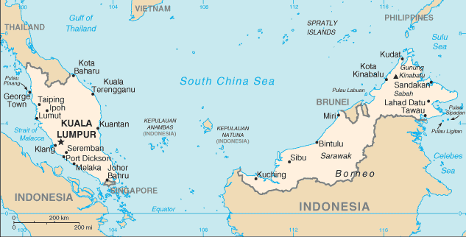

Figure 2.1 Map of Penang
(Maps of World Web Site, 2016)
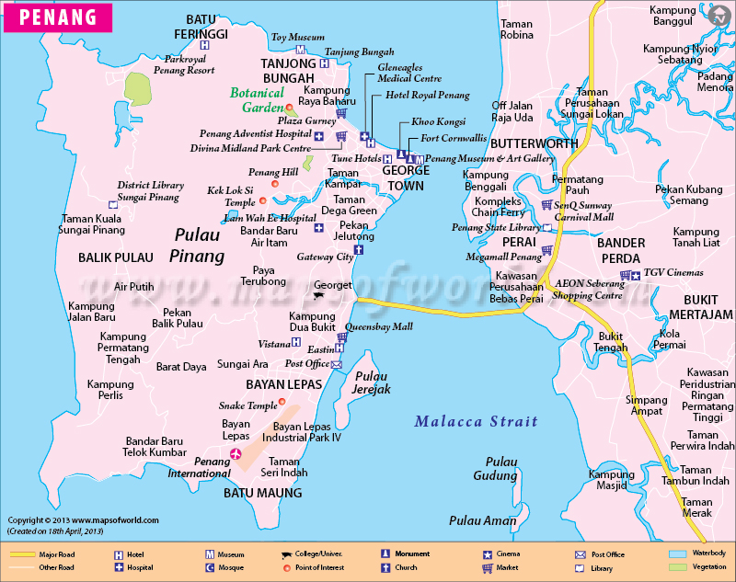
The name of “Penang” comes from the Malay name Pulau Pinang, which means “Island of the areca nut palm”. Penang knew as its heritage, multicultural society, vibrant culture, hill, parks, beaches, shopping and delicious food. Has always been a popular tourist destination domestically and internationally.

Penang consists of two parts, Penang Island and the mainland, Seberang Perai, is one of the 13 states in Malaysia. It’s located in at north-western coast of Peninsular Malaysia, bordered by the state of Kedah in the north and east, the state of Perak in the south and Straits of Malacca in the West. The island is connected to Seberang Perai by ferry and 13.5 Km long Penang Bridge and 24Km long Sultan Abdul Halim Mu’adzam Shah bridge (Official Portal Penang State Government, 2016). An island of covered area of 293Km² in Straits of Malacca, and Seberang Perai about 653 Km².

The Northeast Penang District includes the capital city of George Town, is the administrative, cultural and economic centre. Southwest Penang includes Bayan Lepas Free Industrial Zone, Penang International Airport and Balik Pulau. The population of Penang in 2016 is 1,902,116 where Penang Island has a population of 711,102 and 906,077 populated in Seberang Perai. Ethnic composition in Penang is 41.5% Chinese, 41.7% Bumiputera, 10.0% Indian and 6.5 % is non-Malaysian (Official Portal Ministry of Communications and Multimedia Malaysia, 2016).

2.1 Historical Background

Figure 2.1Map of early Penang in 1786 by Captain H.B Popham
(George Town World Haritage Incorporated, 2016)

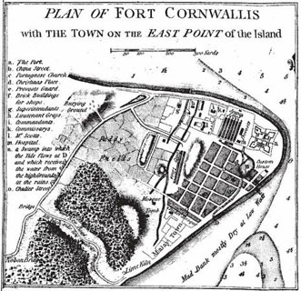

Founded in 1786 by Francis Light in the name of East India Company, the Historic City of George Town was the first British port town along the Straits of Malacca. Entrepreneur and early migrant found George Town a place to make a living and begin a new life. “The site comprises a rich collection of historic buildings, vernacular, administrative and religious, constructed by the European trading settlers under the British East India Company, and later the British colonists, and migrants from various parts of the India-China trading route. These early settlers formed their own neighbourhoods or quarters, centred on certain streets or intersections” (George Town World Haritage Incorporated, 2016).

In early establishment, the European quarter was at the north, at the Fort Cornwallis area and the administrative centre, clustered around St. George Anglican Church and Farquhar Street. The names of the streets of George Town today stand to the original community where the Malay, Chinese and Indians set their settlements.

2.2 George Town UNESCO World Heritage Site

July 2008, Melaka and Georgetown were awarded the title of World Heritage Site by UNESCO World Heritage Committee known as ‘Historic Cities of the Straits of Malacca’. This prestigious title was given as the city rich cultural exchanges between East and West. (UNESCO, 2016) There are three criteria of Outstanding Universal Value (OUV) that given the title of Malacca and George Town. First, Malacca and George Town represent exceptional examples of multi-cultural trading towns in East and Southeast Asia, civilization exchanges of Malay, Chinese, Indian and European cultures, secondly, as living testimony to the multicultural heritage and tradition of Asia, where faith, religions and cultures met and finally, cultural elements have created a unique architecture, shop houses and townhouses, culture and townscape without parallel anywhere in East and South-East Asia (George Town World Haritage Incorporated, 2016).

The Core Area contains more than 1700 Buildings and covers an area of 109.38 hectares, bounded by the coastline along the north and east, and by the Love Lane to the north-west and Gat Lebuh Melayu, Lorong Carnavon to the South West Corner. The Core Area is protected by 150.04 hectares of Buffer Zone bounded by the sea, Jalan Transfer on the west and Jalan Prangin on the south-west (George Town World Haritage Incorporated, 2016).

Identification of George Town UNESCO Cultural Heritage City
(World-heritage-site, 2016)

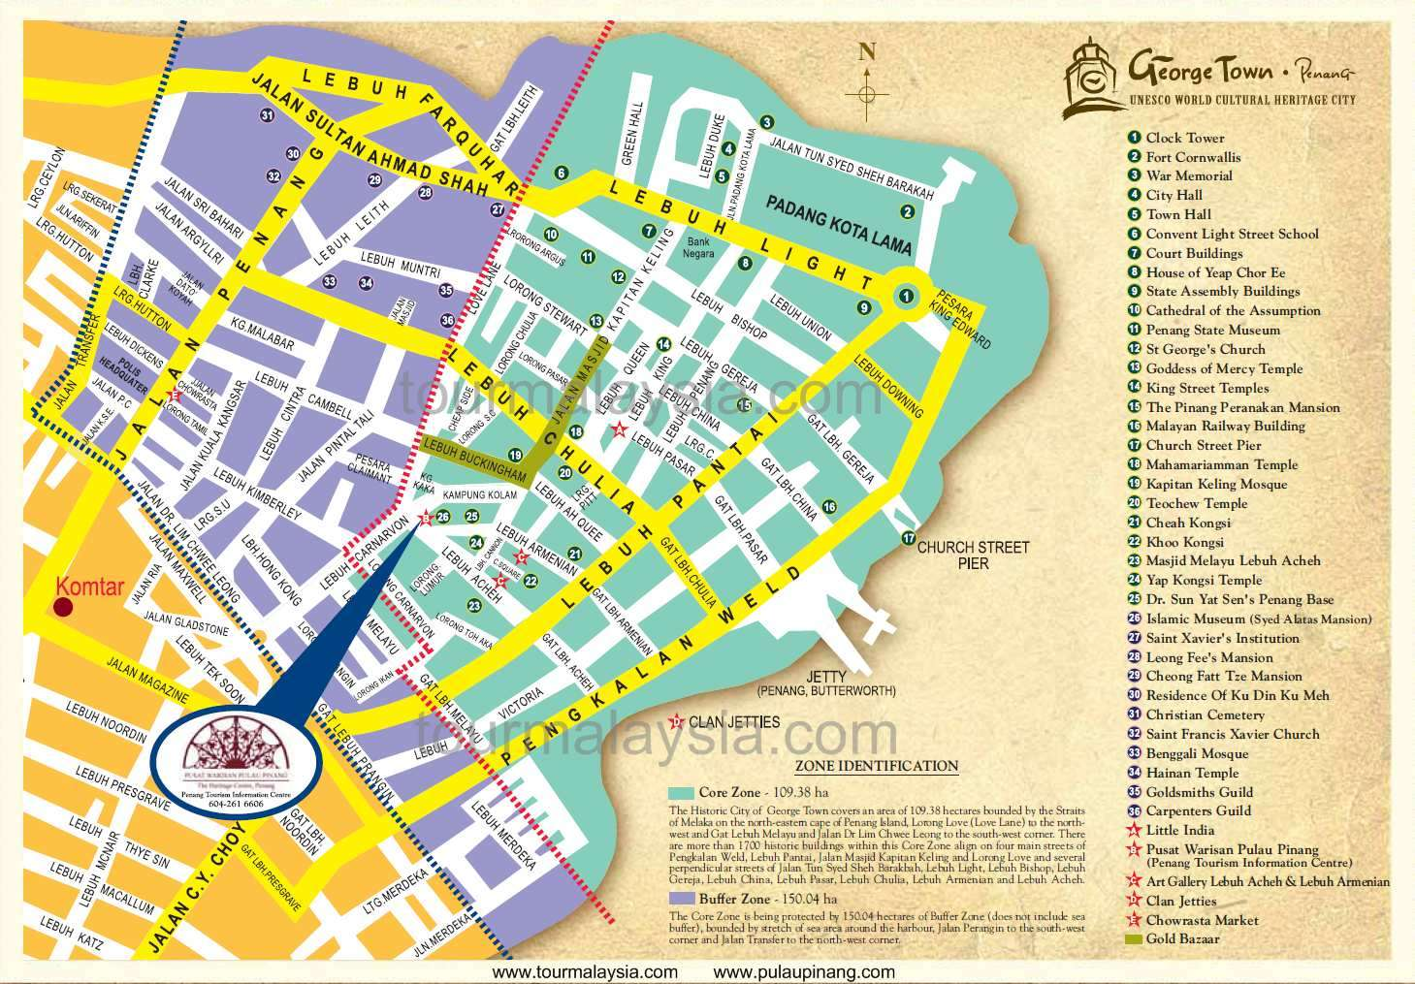

List of places that reflects both tangible and intangible in George Town World Heritage Sites divide by cultural enclave, leisure zone, clan jetties, enterprise zone, the waterfront, heritage traders and business district. Cultural enclave define George Town in richness and variety of, multicultural of Street of Harmonies, kongsis and association such as St. George Church, Sri Maha Mariamman Temple, Noordin Family Mausoleum, Kapitan Keling Mosque, Kapitan Keling Family Mausoleum, Lim Kongsi, Cheah Kongsi, Central Fire Station, Hock Teik Cheng Sri Temple, Syed Al Attas Mansion, Acheeh Street Malay Mosque and Eng Chuan Tong Khoo Kongsi.

Clan Jetties were segregated into distinct communities of clansmen that arrived in George Town for better lives. The jetty was traditionally occupied of the surname and the descendants that occupy the home till today such as Ong Jetty, Lim Jetty, Chew Jetty and Yeoh Jetty. Furthermore, The Waterfront in George Town is the unique symbol of colonial past of George Town. Among others are Swettenhem Pier, Boustead and German merchant houses, Queen Victoria Memorial Clock Tower, Fort Cornwallis, Esplanade, Koh Seang Tat’s Fountain and much more. For Leisure Zone, Cheong Fatt Tze Mansion is a building that won the UNESCO ‘Most Excellent’ Heritage Conservation Award in 2000, Eastern and Oriental Hotel, Penang State Museum, Benggali Mosque, Shaolin Association and St. Francis Xavier’s Church.

The traditional trades and artisans still exist till today as they used to do in George Town years ago and they are called Heritage Traders. Among the traditional traders and artisans are signboard carver, Chinese seal cutter and calligrapher, paper oblation craft man, kapok pillow and mattress maker, coffee roaster, rattan weaver, stonemason and tombstone engraver, shoemaker with Nyonya Beaded shoes, perfume, printing press and bookbinder, spice merchants, Indian goldsmith, songkok maker, joss stick maker, nasi kandar sellers . Flower garland makers and sarong and textile traders.

3.0 METHODOLOGY

Employing stratified random sampling technique, the survey was conducted either face-to-face interviews with the respondents by enumerators or by self-completion at selected tourist attraction in Chiang Mai (e.g. Armenian Street, Love Lane, Padang Kota, Batu Ferringhi) and the gateways to Penang namely Penang International Airport, Malaysia. Enumerators screening the respondents at the beginning, to verify that the respondents were a tourist and not the day trippers and transients visitors.

4.0 ANALYSIS

PROFILE OF VISITOR

Gender | Frequency | Total
Male | 47 | 47.0%
Female | 53 | 53.0%
Total | 100 | 100.0%
Age
18-25 years old | 31 | 31.0%
26-35 years old | 34 | 34.0%
36-49 years old | 21 | 21.0%
≥ 50 years old | 14 | 14.0%
Total | 100 | 100.0%
Marital status
Single | 56 | 56.0%
Married | 38 | 38.0%
Divorce/widowed | 6 | 6.0%
Total | 100 | 100.0%
Highest Level of Education
Higher Degree – Master/PhD | 40 | 40.0%
Tertiary Education-Diploma/Degree | 42 | 42.0%
Secondary/High School Education | 17 | 17.0%
Primary/Elementary Education | 0 | 0.0%
No Formal Education | 1 | 1.0%
Total | 100 | 100.0%

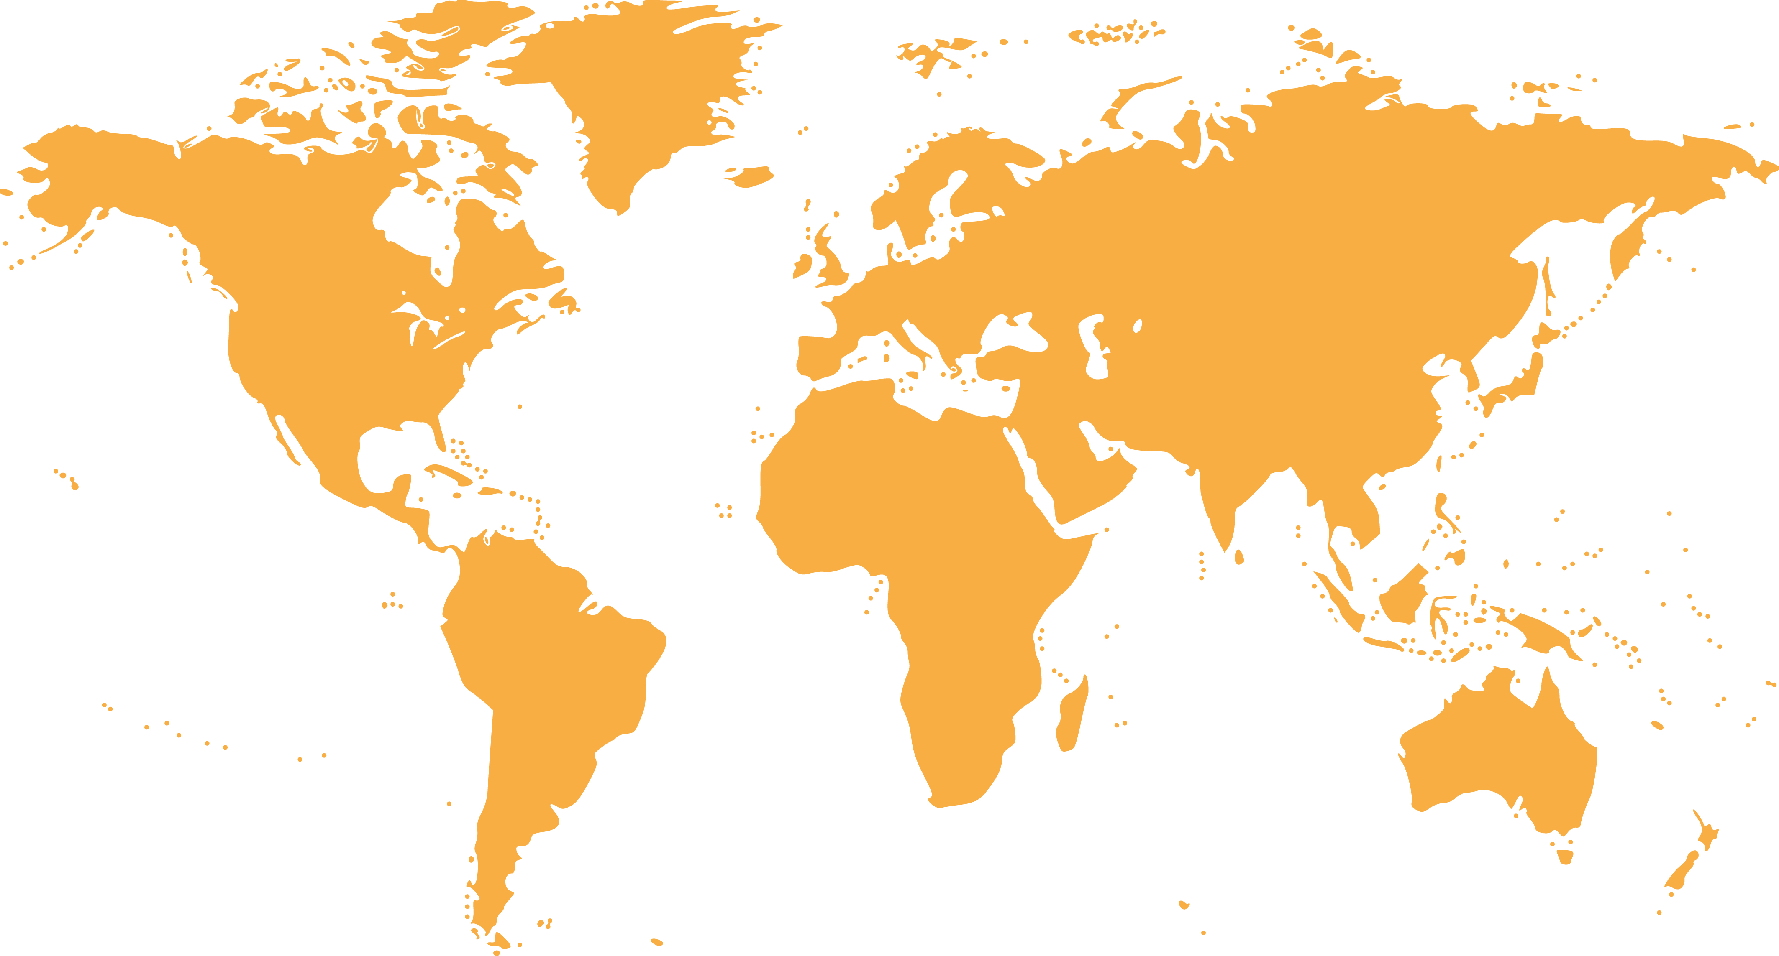

4.0%
Eastern
Asia

7.0%
Oceania

20.0%
Southeast
Asia

0.9%
Southern
Asia

0.0%
Africa

1.0%
Western
Asia

54.0%
Europe

12.0%
Americas

Country of residence | Frequency | Total
Southeast Asia | 20 | 20.0%
Western Asia | 1 | 1.0%
Eastern Asia | 4 | 4.0%
Oceania | 7 | 7.0%
Europe | 54 | 54.0%
Americas | 12 | 12.0%
Sothern Asia | 2 | 2.0%
Africa | 0 | 0.0%
Total | 100 | 100%

MAIN PURPOSES OF TRAVEL

1. Leisure/recreation
2. Education/teaching/training
3. Culture and heritage

Main Purpose of Travel | Frequency | Total
Leisure/recreation | 50 | 52.6%
Education/teaching/training | 15 | 15.8%
Culture and heritage | 10 | 10.5%
Health treatment | 8 | 8.4%
Visit friends/relatives (VFR)/back to hometown | 7 | 7.4%
Business/meeting | 3 | 3.2%
Shopping | 1 | 1.1%
Convention/conference/trade show/ exhibition | 1 | 1.1%
Religious/pilgrimages | 0 | 0.0%
Sporting | 0 | 0.0%
Others | 0 | 0.0%
Total | 100 | 100.0%

IMAGES OF PENANG

The majority of visitors perceived the images of Penang as:

1. World Heritage Site
2. Local Cuisine
3. Multicultural Society

Image of Penang | Frequency | Total
World Heritage Site | 61 | 40.9%
Local Cuisine | 30 | 20.1%
Multicultural society | 22 | 14.8%
Sandy Beaches | 8 | 5.4%
Safe Destination | 7 | 4.7%
Shopping Paradise | 6 | 4.0%
Healthcare Destination | 5 | 3.4%
Modern City Life | 3 | 2.0%
Hills/jungles/green | 3 | 2.0%
Cultural Performance | 1 | 0.7%
Education Hub | 1 | 0.7%
Nightlife Entertainment | 1 | 0.7%
International events | 1 | 0.7%
Traditional | 0 | 0.0%
Total | 149 | 100.0%

FACTORS INFLUENCED VISITOR’S DECISION TO TRAVEL

Statement | Not Influential at all | A little bit Influential | Somewhat influential | Influential | Very Influential | Total
Positive Image | 3.0% | 4.0% | 12.0% | 54.0% | 27.0% | 100%
Heritage sites, culture, arts and tradition | 4.0% | 3.0% | 14.0% | 48.0% | 31.0% | 100%
Friendliness of local people | 3.0% | 4.0% | 18.0% | 48.0% | 27.0% | 100%
Safety level of destination | 9.0% | 4.0% | 22.0% | 38.0% | 27.0% | 100%
Convenience of Visa | 18.0% | 4.0% | 21.0% | 26.0% | 31.0% | 100%
Affordability of the destination | 4.0% | 1.0% | 20.0% | 38.0% | 37.0% | 100%
Urban landscape | 6.0% | 8.0% | 40.0% | 30.0% | 16.0% | 100%
Food | 3.0% | 7.0% | 22.0% | 36.0% | 32.0% | 100%
Natural scenery | 2.0% | 2.0% | 13.0% | 52.0% | 31.0% | 100%
Geographically close | 19.0% | 9.0% | 16.0% | 31.0% | 25.0% | 100%
Climate | 2.0% | 9.0% | 30.0% | 38.0% | 21.0% | 100%
Hygiene level | 15.0% | 12.0% | 27.0% | 35.0% | 11.0% | 100%
Beautiful beaches | 9.0% | 9.0% | 20.0% | 45.0% | 17.0% | 100%
Shopping experience | 21.0% | 8.0% | 28.0% | 33.0% | 10.0% | 100%
Festival and events | 24.0% | 6.0% | 26.0% | 35.0% | 9.0% | 100%
Nightlife | 29.0% | 5.0% | 25.0% | 33.0% | 8.0% | 100%
Outdoor activities | 15.0% | 4.0% | 27.0% | 42.0% | 12.0% | 100%
Level of ICT infrastructure | 16.0% | 11.0% | 27.0% | 33.0% | 13.0% | 100%
Status of destination (e.g. world heritage) | 7.0% | 12.0% | 18.0% | 47.0% | 16.0% | 100%
Interesting amusement/theme parks | 23.0% | 9.0% | 32.0% | 29.0% | 7.0% | 100%
Similarity of culture | 38.0% | 22.0% | 17.0% | 14.0% | 9.0% | 100%
Same religion | 58.0% | 8.0% | 11.0% | 13.0% | 10.0% | 100%
Statement | Not Applicable | Poor | Below Average | Average | Good | Excellent
Hospitality of immigration officials at the entrance point | 3.0% | 2.0% | 5.0% | 22.0% | 39.0% | 29.0%
Check in/check-out process at the airport | 4.0% | 1.0% | 3.0% | 27.0% | 34.0% | 31.0%
Availability of information at entry points | 5.0% | 1.0% | 4.0% | 26.0% | 36.0% | 28.0%
Local public transport services | 5.0% | 4.0% | 9.0% | 23.0% | 32.0% | 27.0%
Accessibility of tourist attractions | 4.0% | 1.0% | 3.0% | 20.0% | 46.0% | 28.0%
Prices of local public transportation | 6.0% | 2.0% | 2.0% | 16.0% | 43.0% | 27.1%
Availability of accommodation | 2.0% | 0.0% | 5.0% | 15.0% | 45.0% | 33.0%
Quality of accommodation | 1.0% | 0.0% | 1.0% | 22.0% | 48.0% | 28.0%
Hospitality of hotel staff | 1.0% | 0.0% | 4.0% | 18.0% | 41.0% | 36.0%
Price of accommodation | 2.0% | 0.0% | 4.0% | 13.0% | 52.0% | 29.0%
Internet connectivity/WIFI | 2.0% | 6.0% | 11.0% | 14.0% | 43.0% | 24.0%
Money changer/automatic teller machine (ATM) | 8.0% | 1.0% | 7.0% | 22.0% | 39.0% | 23.0%
Shopping facilities | 11.0% | 0.0% | 9.0% | 11.0% | 50.0% | 19.0%
Public toilets | 12.0% | 5.0% | 12.0% | 22.0% | 37.0% | 12.0%
Signage at attraction | 6.0% | 3.0% | 7.0% | 35.0% | 32.0% | 17.0%
Tourist information centre | 8.0% | 0.0% | 4.0% | 32.0% | 40.0% | 16.0%
The price of goods | 3.0% | 0.0% | 2.0% | 27.0% | 49.0% | 17.0%
Variety of tourist attraction | 1.0% | 4.0% | 5.0% | 24.0% | 45.8% | 29.0%
Nightlife entertainment | 12.0% | 0.0% | 8.0% | 18.0% | 39.0% | 23.0%
Cleanliness of beaches and ocean | 6.0% | 4.0% | 4.0% | 25.0% | 46.0% | 15.0%
Price of food and beverages | 0.0% | 0.0% | 4.0% | 18.0% | 53.0% | 25.0%
Cleanliness of eating places | 1.0% | 1.0% | 8.0% | 35.0% | 41.0% | 14.0%

PENANG TRAVEL SATISFACTION
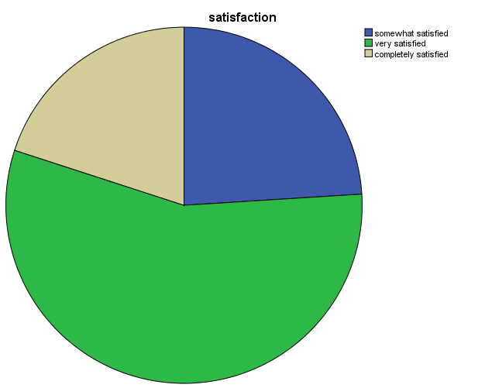

Average satisfaction score 3.96/5.00

Not all satisfied : 0.0%
Slightly satisfied : 0.0%
Somewhat satisfied : 24.0%
Very satisfied : 56.0%
Completely satisfied : 20.0%

PENANG REVISIT INTENTION

WILLINGNESS TO RECOMMEND PENANG
Revisit the city in the future | Frequency | Total
Yes | 91 | 91.0%
No | 9 | 9.0%
Total | 100 | 100.0%

Recommendation the city to others | Frequency | Total
Yes | 79 | 79.0%
No | 21 | 21.0%
Total | 100 | 100.0%

What tourist LIKE about Penang city?

No | Like | Frequency
1 | Foods | 20
 | Friendly People | 8
2 | Culture | 6
3 | Street Art | 3
4 | Heritage Building | 3
5 | Beautiful City | 1
6 | History | 1
7 | National Park | 1

What tourist DISLIKE about Penang city?

No | Dislike | Frequency
1 | Cleanliness | 1
2 | Crowded | 1
3 | High Price | 1
4 | Spicy Food | 1
5 | Traffic | 1

What are DIFFICULTIES tourists encounter?

No | Difficulties | Frequency
1 | Cleanliness | 3
2 | Congested Road | 2
3 | Spicy Foods | 2
4 | High Price for Tourist | 1
5 | Weather | 1

References

George Town World Heritage Incorporated. (2016, November 29). George Town World Heritage Incorporated. Retrieved from George Town World Heritage Incorporated Web Site: http://www.gtwhi.com.my/introduction/george-town-world-heritage-site.
Maps of World Web Site. (2016, November 28). Retrieved from mapsofworld.com: http://www.mapsofworld.com/malaysia/penang-map.html
Official Portal Ministry of Communications and Multimedia Malaysia. (2016, November 30). Official Portal Ministry of Communications and Multimedia Malaysia. Retrieved from Official Portal Ministry of Communications and Multimedia Malaysia Web Site: http://www.kkmm.gov.my/
Official Portal Penang State Government. (2016, December 4). Penang.gov.my. Retrieved from Official Portal Penang State Government: https://www.penang.gov.my
Penang Vacations.com. (2016, December 3). Penang Vacations. Retrieved from Penang Vacations Web Site: http://www.penang-vacations.com/penang-maps.html
UNESCO. (2016, November 30). UNESCO World Heritage Centre Corporation. Retrieved from UNESCO World Heritage Centre: http://whc.unesco.org/
World-heritage-site. (2016, December 2). World-heritage-site. Retrieved from World-heritage-site Web site: http://www.world-heritage-site.com/

