Tourism and Kimono in Kyoto: Images and Commodification

Introduction

Kyoto is a city of charm to fascinate tourists from all over the world. Because the old capital with the historical, cultural activities and beautiful temples and it is an authentic cultural experience that will unexpectedly leave all visitors with many beautiful photos and memories. Kyoto has hundreds of temples and shrines, which served as Japan’s main seat of government from the 8th to 17th centuries.
People such as the emperor family, shoguns, priests and politicians required beautiful clothing and Kyoto therefore became a major center for the textile industry, and by default the center for kimonos. Currently in most of Japan, Kimonos are mainly worn for special occasions such as official holidays, however Kyoto remains one of the few cities where people wearing kimonos can still be seen frequently.

Thus, in order to safeguard the traditional industries and retain the artistry involved in this cultural icon as well as to promote Kyoto’s heritage the cities officials developed programs that would encourage people to wear kimonos more often. Many temples, museums, transportation such as subway now offer discount to men and women wearing Kimonos. Restaurants are now doing the same. And not only residents but also tourists. Tourists are encouraged to rent or buy Kimonos to wear in especially the old town areas in Kyoto.

Besides, Kimono - a symbol of traditional attire of Japan. The Japanese word ‘ki’ means ''to wear'' and ‘mono’ means ''thing''. The Kanji for the word Kimono simply means ''thing to wear''. Until the Second World War, over 90% of Japanese women wore kimono in their daily life. Today, the Kimono is part of the history of Japanese women depending on their age and generation. Women typically wear a Kimono anywhere from once every few years to a few times a year for attending weddings, funerals and other special occasions. But wearing a Kimono could be confining and difficult to put on. However, there are many new methods and services to enjoy Kimono in more fun and easy ways in Kyoto.

The mostly highlighted activity for being in Kyoto is transforming oneself into a charming native Japanese in a form of Kimono-figure and emulate all things as Edo era. The Kimono is the signature that makes every visitor to Japan expects to see during their travels especially in Kyoto.

This study focuses on the influence of Kyoto images as the former capital of Japan can attract tourists both Japanese and foreign tourists to visit Kyoto and to wear Kimono in Kyoto. It is previously found that there is not such of the research study, especially in English, on this topic yet. This study can increase knowledge regarding to the growth of tourism industry in Kyoto, as well as tourism and Kimono in Kyoto.

Kyoto as a former capital of Japan

As a former capital of Japan, famous worldwide for its temples and shrines. Kyoto has been the center of politics and culture for 1,100 years. Kyoto Prefecture stretches out from the southeast to the northwest in the central and northern parts of the Kansai region. It has four geographical features, the saw-toothed coastal area around Maizuru Bay in the northeast, the Tanba Mountains around its center, the Kyoto Basin in the southeast, and the Yamashiro Basin.

Kyoto became the capital of Japan in the 8th century. It flourished as the center for Japanese politics, economy and culture for 1,100 years, until the capital functions were transferred to Tokyo in the mid-19th century. There remain many temples and shrines in Kyoto that were built during this long period. Seventeen historic sites including, Kiyomizu-dera Temple and Nijo Castle, are inscribed as World Cultural Heritage Sites.

Kyoto: A center of traditional Japanese culture

The ancient capital of Kyoto, whose traditions have been matured through the ages, is now making startling advancements. Its rich culture and experience are being utilized in modern technological industries. For example, semiconductor and liquid crystal displays have been made based on the techniques of Kiyomizu Pottery. Traditional skills developed more than 1000 years in this ancient capital are now being utilized in cutting-edge technologies.

Furthermore, the people of Kyoto have produced many religious arts and forms of entertainment. Countless religious Shinto rituals and festivals have captured the imagination of people the world over. Among these, festivals such as Gion Matsuri that were lost in the turmoil of war have been restored, and continue to be carefully maintained traditions. Although, the festivals in Kyoto are famous not only in Japan, but are also known worldwide. Also, Kyoto remains the home of traditional Japanese cuisine, and there are many specialty eateries for sushi, tempura, soba, and ramen. It was the efforts of Kyoto chefs that resulted in “Washoku,” or Japanese cuisine, being recognized as an intangible heritage by UNESCO in 2013. Kyoto is also famous throughout Japan for traditional Japanese sweets, some of which are used in the Japanese tea ceremony (the tea also comes from Kyoto).

As an ancient capital of Japan, Kyoto has been center of traditional Japanese culture in Japan, for instance, traditional beliefs, arts and crafts, festivals, and food.

Kyoto: A popular city for tourists to visit

Kyoto has been ranked the most popular tourist destination worldwide for 2 years consecutively by “Travel + Leisure”, a famous travel magazine in the US. With a total number of 55 million Japanese and international tourists visiting Kyoto annually, it is one of the world’s leading tourist destinations that boasts an astonishing number of 17 UNESCO World Heritage Sites.

Kyoto is one of the most popular travel destinations in Japan for both domestic and foreign tourists alike, Kyoto is an ancient city with over a thousand years of history. Today, Kyoto is a historical city that's popular with tourists from around the globe. It has over 2400 temples and shrines. Many travelers consider it to be the most beautiful city in the world.

Aims of this study
This study aims to investigate the influence of Kyoto images to the visits of tourists and the transformation of the Kimono rentals in Kyoto.

Methodology
The research is conducted through qualitative research method. Data of this study are based on documents, textbooks and data from interviewing the Kimono shopkeepers and owners, as well as tourists who dressed in Kimono, in Gion and Kiyomizu area.

Results of the study
It is found that;
- There are increasing numbers of foreign tourists, for instance, Chinese, Korean and Taiwan tourists in Kyoto. Those tourists also intend to wear Kimono during their visits Kyoto. This is due to the economic growth and rapid development, especially transportation development in the present societies that have led to an increasing numbers of tourists.
- The increasing numbers of foreign tourists, especially Chinese, Korean and Taiwanese, who expect to wear Kimono in Kyoto, results to the increasing number of the Kimono rental shops in Kyoto, especially in Gion and Kiyomizu area.
- Accordingly, there are increasing numbers of the Kimono rentals in Kyoto due to the increasing number tourists. Numbers of Kimono rentals in Gion and Kiyomizu are increased around 40 percent compare from the last two years.
- Surprisingly, the owners of many new established Kimono rental shops in Gion and Kiyomizu are Chinese. It is also found that these Chinese investors used to work in tourism industry in Kyoto, for instance, in tour operator business, and in Kimono retail shops. In this way, they learnt tourism growth in Kyoto, as well as the growth of Kimono rental business.

- Modern marketing promotion is used by the young owners of modern Kimono rentals. They use of internet marketing system to attract their customers. This way, photographs of tourists wearing Kimono are posting to attract their customers. It is found that most of the tourists who came to rent Kimono search data for the Kimono rentals from the internet.
- Customers’ languages are another strategy to trap the customers. Thus, the websites of these Kimono rentals provided many languages to facilitate their customers, for instance, Japanese, English, Chinese and Korean language. This modern marketing strategy gains more customers and economic benefits to those modern Kimono rentals in Kyoto.
- Kimono design are also changed to match tourists demand. It is found that tourists from different countries demanding for different colour and design of Kimono. For instance, the Chinese tourists like to rent colourful Kimono in red flowers design, while Korean tourists like to wear pinky Kimono design. Differently, Japanese customers like to rent the classic design of Kimono which are made in Japan.
- Demanding of tourists to Kimono design result to the import of Kimono from China and Korea to Japan. Further, the imported Kimono are cheaper in renting price compare to Kimono which are made in Japan.
- Accordingly, prices to rent different design and style of those Kimono are altered. It is found that prices for classic design Kimono for Japanese tourists are higher from colourful design Kimono for Chinese and Korean tourists. Lis of price and style of Kimono is shown below.

Price | Rent period | Extra service | Gender
2000 | 1 day |  | female
3000 | 1 day | With hair dressing | female
5000 | 1 day |  | female
5500 | 1 day |  | female
5500 | 1 day | With hair dressing | female
6000 | until 9 PM |  | female
7300 | 1 day |  | female
9000 | 1 day |  | female
10000 | 1 day |  | female
11000 | 1 day | With hair dressing | female

Conclusions
This study can be concluded that;
- Wearing Kimono in Kyoto became a popular culture for young tourists. According to the images of Kyoto as an ancient capital of Japan, as well as the old town atmosphere in Kyoto, and photographs of young people wearing Kimono in Kyoto in the websites, these powers can fascinate those young tourists to visit Kyoto. Furthermore, the power of photographs through social media and websites can captivate those young tourists to wear Kimono in Kyoto. Normally, these tourists are always walking around the old town corner in Kyoto and take their photographs in Kimono. Further they always post the photographs in the websites or social media. The process can be seen as a push factor to attract the other young people to visit Kyoto.
- In addition, wearing Kimono in Kyoto can be seen as the ‘popular culture’ of those young tourists, who like to do whatever the others do. In other words, these young tourists would like to perform in the same ways that other young tourists did in Kyoto.
Further, photographs of wearing Kimono can be seen as a push factor to persuade the other young tourists to wear Kimono in Kyoto, at least once in their life time.
- It can be seen that images of Kyoto and Kimono, a traditional Japanese costume, has been commoditized to tourists. In other words, Kyoto images has been sold as commodity to tourists. When commodification means the transformation of goods, services, ideas and people into commodities, or objects of trade. This way, images of Kyoto and traditional culture are sold as commodity for economic reasons.

References

JNTO.(2017).Kyoto. Retrieved March 25, 2017, Sourced from Japan National Tourism Organization Web Site : http://www.jnto.go.jp/eng/location/regional/kyoto/

KYOTO Prefectural Government Tourism Division.(2017). Kyoto history. Retrieved March 25, 2017, Sourced from Kyoto Prefecture's Web Site : http://www.pref.kyoto.jp/visitkyoto/en/info_required/kyoto_history/

Jun Hongo. (2015). Among Travel + Leisure Readers. Retrieved March 25, 2017,
Sourced from wall street journal Web Site: http://blogs.wsj.com/japanrealtime/2015/07/08/kyoto-chosen-as-top-global-destination-by-travel-leisure-readers/

Savor Japan.January, 2017. Delectable Diversity at These 11 Kyoto Station Restaurants. Retrieved March 25, 2017, Sourced from SavorJapan Web Site: https://savorjapan.com/column/location/kyoto/delectable-diversity-at-these-11-kyoto-station-restaurants/index.html#more-1116

Andi Fisher (2014). Kyoto’s Kimono Culture. Retrieved March 25,2017, Sourced from: Misadventures with Andi Web site: http://misadventureswithandi.com/kyotos-kimono-culture.html

Interview
Around 15 of shop keepers and owners of Kimono rentals were interviewed in October 2016, including the interviewing of around 30 tourists in Gion and Kiyomizu area.

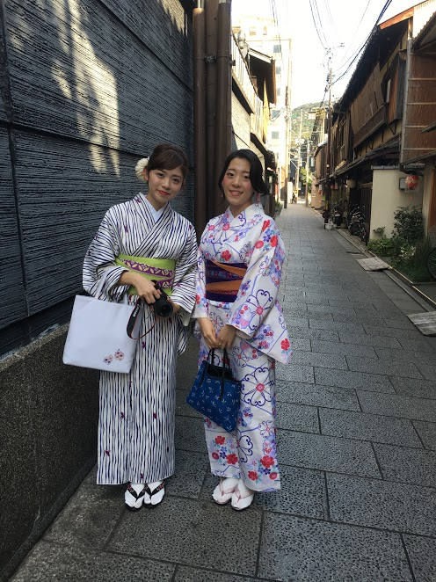

Figure 1: Japanese tourists in Kimono

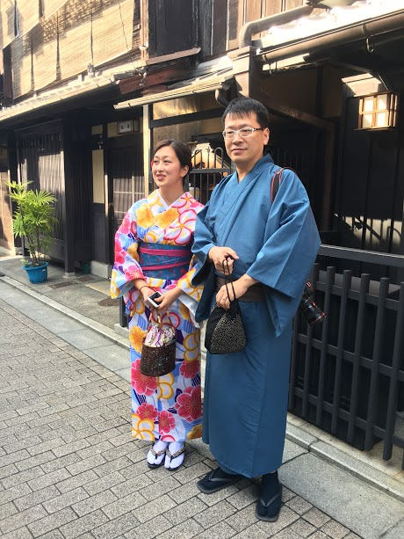

Figure 2: A couple tourists from Taiwan

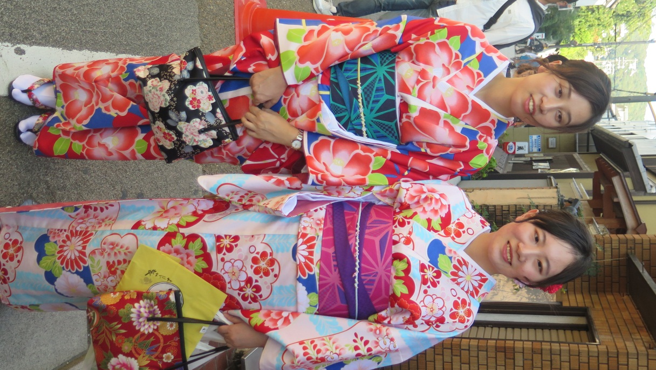
Figues 3: Young female tourists from Taiwan
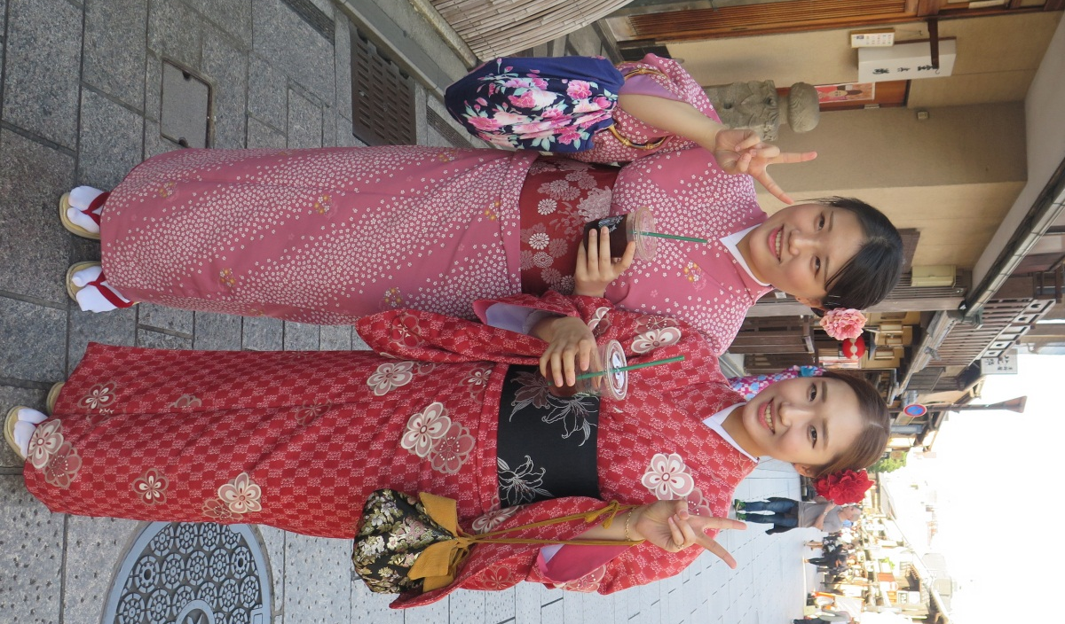
Figure 4: Two Chinese tourists in Gion area

Figure 5: A Chinese Kimono rental owner in Gion

