Tourism and Water Puppetry in Hanoi
Introduction
Water puppetry, or making puppets dance on water, a local tradition which can date back to 11th century in the villages of the Red River Delta area of northern Vietnam. After, it was brought into Hanoi and then was known as a national performance. Later, it was developed into tourist attraction in theaters in Hanoi. Therefore, the water puppet performance has been changed in many ways. It is likely be a promising performance for tourism industry in Hanoi since it offers tourists a unique experience to enjoy the local traditional performance. Further, it can increase tourist’s knowledge about the origin of Vietnamese lifestyle and allow tourists to watch a unique celebration of Vietnamese farmers in the wetland area of Red River Delta through the water puppet performance. Not only tourists, the performance can also encourage many of Vietnamese young people to pay more attention in their own national show. Regarding, water puppet show in Hanoi’s theatres can remain the real traditional Vietnamese lifestyle. It is seen that water puppet show in Hanoi became more popular for tourists in Hanoi. This can reveal through increasing number of tourists as audience for the show.
This study focuses on the transformation of Water Puppet, the traditional performance of local people in Red River Delta, when it was brought into the unique Vietnamese national performance and then a show for tourists in Hanoi’s theatres.

History of water puppetry in Vietnam
Water puppetry, or Making puppets dance on water, was first appeared in the 11th century at the villages around the area of the Red River Delta in northern Vietnam. The farmers created this art form to pray for nourish in rice crop for instance at the end of the rice harvest, religious festivals, and other important occasions. The dragon is particularly the strong character. Red River Delta, the origin of Water Puppet performance, was the area of humid and filled with rivers. When the rice fields would flood, the villagers would entertain each other using this form of puppet play. Further, the village ponds were also used to perform the water puppetry.
Originally, water puppet was performed by the farmers and for the other villagers who were their neighbors. Each performance contains with 20-30 scenes in which telling water in Vietnamese people’s daily life. These scenes are a fish catching, feeding ducks in a village pond, peasant couple on their basket-boat, peasant girls bringing offerings to the pagoda, buffalo rides in an opium pipe, hero fights a tiger, getting into a Palanquin, dismounting a horse and procession in five directions.
The puppets are made out of wood and then lacquered. The show is performed in a waist-deep pool. A large bamboo rod supports the puppet under the water and is used by the puppeteers, who are normally hidden behind a screen, to control them. Thus the puppets appear to be moving over the water. Up to 8 puppeteers stand behind a split-bamboo screen, decorated to resemble a temple facade, and control the puppets using long bamboo rods and string mechanism hidden beneath the water surface. The puppets are carved out of wood and often weigh up to 15 kg.
A traditional Vietnamese orchestra provides background music accompaniment. The instrumentation includes vocals, drums, wooden bells, cymbals, horns, Đàn bầu(monochord), gongs, and bamboo flutes. The bamboo flute's clear, simple notes may accompany royalty while the drums and cymbals may loudly announce a fire-breathing dragon's entrance
Puppetry tells how Vietnamese farmers live together with water and spirit in the pantheism atmosphere. The water puppet was well known performed at capital city at Thang long puppet theater and it was particularly designed for holding cultural events especially puppet dancing show or known as “Water puppet” nowadays.

Water Puppet in Hanoi
In 1956, President Hồ Chí Minh watched a puppetry performance by the Radost troupe from Czechoslovakia. Following the performance, the President invited the Radost troupe to help establish a national Vietnamese puppetry group mainly focused on Hand puppet that originated from Czechoslovakian with the first technique: hand-and-rod puppetry. From 1956 to 1958, the Vietnamese government created a policy to preserve the local arts. This way, the national artists went to the local villages and rural parts of Northern Vietnam to study and analysis the practices of the local people and water puppeteers and finally learnt such of this kind of art. This initiative, instigated by President Hồ Chí Minh, was the starting point to turn water puppetry become the national performing art of Vietnam.
In 1956 Nhà hát Múa rối Việt Nam or Vietnam National Puppetry Theatre was established under the support by Vietnamese government with the policy about preserving the art of nation. This theatre is in rường Chinh Street, Hanoi. By that time, water puppet became more and more popular for the tourist and it was the first time for capital city like Hanoi to have the water puppet theatre. Many years later Hanoi is full of Water puppet theatre and eventually became tourist attraction.
In 1969, Thang Long Water Puppet Theatre was found as the one of the best places to watch the art of Vietnamese Water Puppetry. Today, Thang Long Water Puppet Theatre is one of a few traditional theatres still in operation the wooden lacquered puppets to the world. At a stage performance, puppeteers stand waist deep in the water and hidden themselves behind a bamboo screen. They spectacularly control the puppet with a long, submerged rod. There is a live orchestra which present traditional music and also for its comical performances.

Aims of this study
This study aims to explore the transformation of the water puppetry after the performance was brought into the national performance and then as tourist attraction at the Thang Long Theatre in Hanoi.

Methodology
Qualitative research method is conducted in this research study. Data of the water puppetry in Vietnam are based on documents, textbooks. Interviewing related informants, including tourists are also organised, besides watching the water puppet performance at the Ethnology Museum and Thang Long Theatre in Hanoi.

Results of the study
It is found that;
- The puppeteers who manage Water Puppetry at the Thang Long theatre are not the villagers form villages of Red River Delta, the origins of the performance. They are young Vietnamese artists who are trained from the National Art Colleges in Vietnam.
- The audience of the Thang Long Theatre are mostly tourists in Hanoi.
- Water Puppetry at Thang Long Theatre are selected from major scenes of the show from different villages in the Red River Delta.
Conclusion
It can be concluded that;
- According to the national policy to preserve the local arts, in 1956 the government brought the water puppetry from the villages into national performance in Hanoi. Then the Vietnam National Puppetry Theatre was constructed to perform traditional art to the national guests. Later the Thang Long Theatre was found. Then Water Puppetry became into tourist attraction in Hanoi.
- It is found that not only the puppeteers who manage puppets are not the villagers in Red River Delta, the audience of the puppetry are also not the villagers as it was in the past.
- This way has changed the puppetry, which used to be the local performance by the villagers and for themselves during their cerebrations or local festivals, into the performance which is managed by the ‘others’ and for the ‘others’. The meaning of the water puppetry has changed from its original one.
- The process can reviewed the transformation of the Vietnamese traditional performance into tourist attraction of Hanoi, the capital of Vietnam.

References

Gaboriault, Derek, " Vietnamese Water Puppet Theatre: A Look Through The Ages " (2009). Honors College Capstone Experience/Thesis. Projects. Paper 205. Sourced from: http://digitalcommons.wku.edu/stu_hon_theses/205

MA Student in Southeast Asian Studies Program, “Water Puppetry and Peasants' Life in Vietnam.” Journal of Mekong Societies, vol. 1, No. 3, 2005, pp. 47-75.
Richard, Phillips, “A unique form of art” 1999, https://www.wsws.org/en/articles/1999/02/viet2-f05.html?view=article_mobile. Accessed 29 March 2017
Sarisa Prateepchuang, Supunnnee Leauboonshoo and Truong Ngoc Thang. 2016. The musical heritage of water puppet performance in Hanoi, Socialist Republic of Vietnam. Wacana Seni Journal of Arts Discourse 15: 95–112. http://dx.doi.org/10.21315/ws2016.15.4
Revolinski, Kevin, “Vietnamese Puppetry: Just Add Water” 2012, http://themadtraveler.com/articles/vietnamese-puppetry-just-add-water. Accessed 29 March 2017

Pham, Hoang Hai. Vietnamese Water Puppetry. The Gioi, 2007.

ศิลปกิจ ตี่ขันติกุล. หุ่นน้ำ :พัฒนาการของโรงหุ่นแห่งชาติและศิลปะทางการของประเทศเวียดนาม. กรุงเทพฯ: คณะสังคมวิทยาและมานุษยวิทยา มหาวิทยาลัยธรรมศาสตร์, 2545.

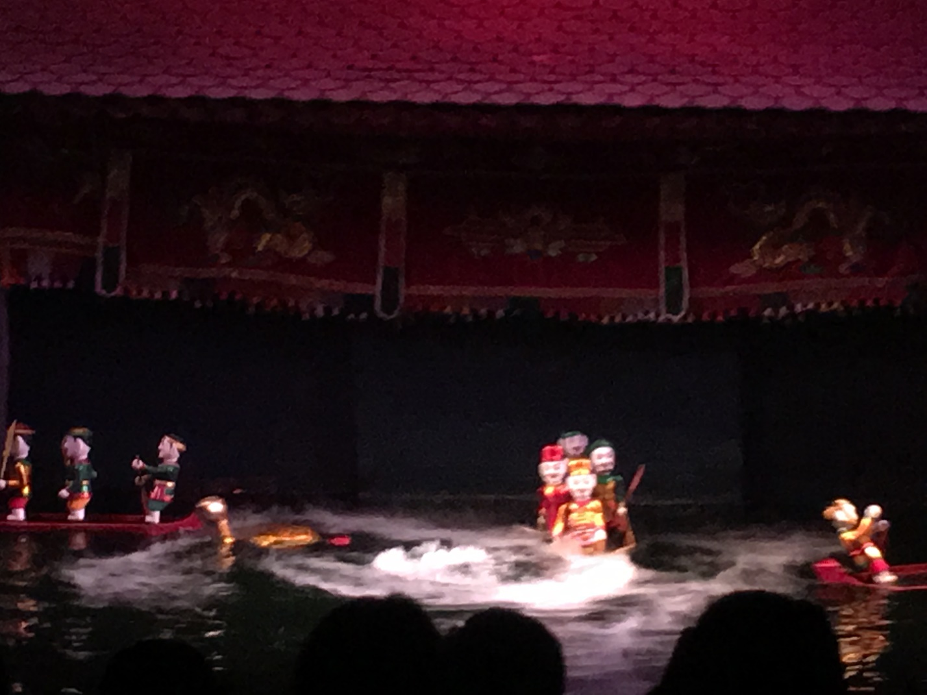

Figure 1 : Water Puppetry at Thang Long Theatre, Hanoi

Figure 2: Puppeteers at Thang Long Theatre
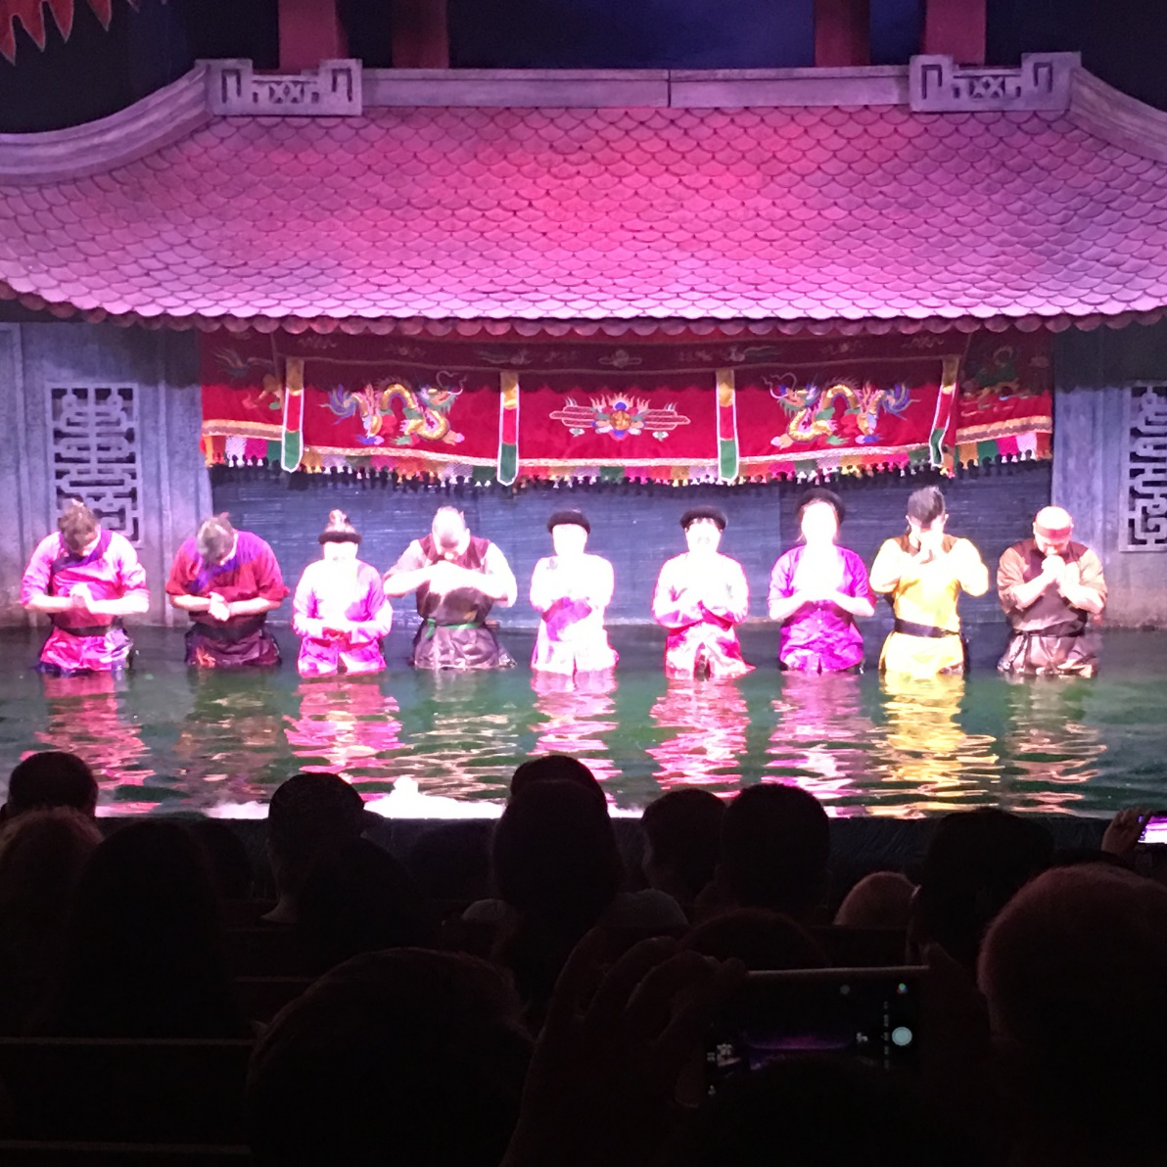

Figure 3: Western tourists as audience of Water Puppetry

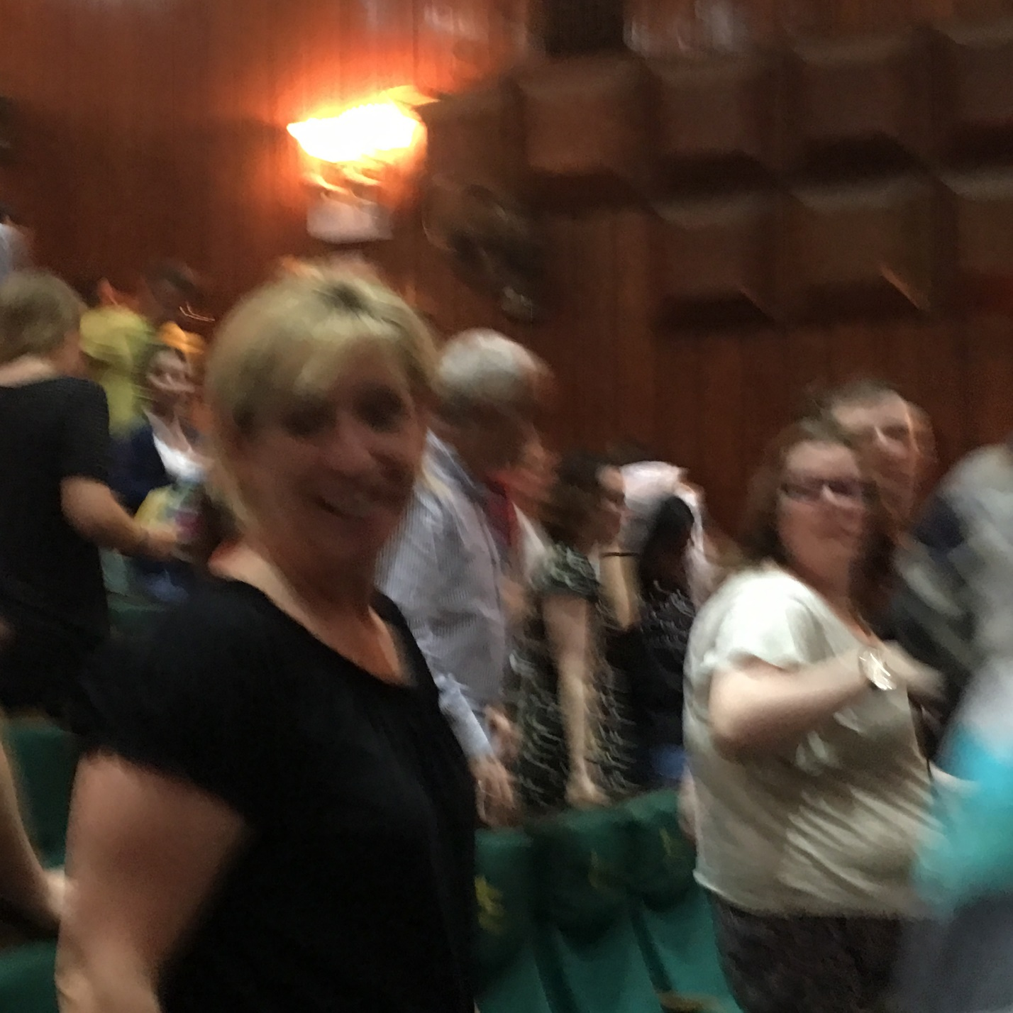
Figure 3: Western tourists as audience of Water Puppetry at Thang Long Theatre

